

Project Modification Request

9.1 Financial System Campus Users

6/2014

Project Modification Request

INTRODUCTION:
The Project Modification Request (PMR) Module has been created within the Financial System to help streamline the Project Modification process. This new module will provide a more efficient and relatively easy method for campus users to submit and track Project Modifications. The PMR module will provide multiple college approval functionality, along with enhanced transparency, during the life of a request.

PMR VS CHARTFIELD REQUEST SYSTEM:

Chartfield Request System
For Contract & Grant Projects (i.e., ledger 5s), the Chartfield Request System should ONLY be used to request a New Segment - ADD, to INACTIVATE existing segments, or to MODIFY attribute information on an existing segment.
PMR
The Project Modification Request System should be used to submit the following type of requests for Contract & Grant Projects (i.e., ledger 5s):

Type of award actions that will require a Project Modification Request

- Budget Modification
- Carry Forward

- Change in PI / Key Personnel

- Change in Scope

- Domestic & Foreign Travel

- Equipment Acquisition
- Fabricated Equipment
- No Cost Extension

- Pre-Award Cost

- Subaward

- Other

How to gain access to PMR:

A SARs REQUEST IS NOT REQUIRED TO GAIN ACCESS TO PMR
  - A PI is granted access to PMR via the PI Table. The PI Table is a database containing the Principal Investigator names and associated role (i.e., lead or Co-I). This information is fed nightly from RADAR. The PI Table also provides access to the PI Portal, and other systems.

  - A Department Bookkeeper, Contract Manager or Grant Manager (i.e., GADM Role) access will be granted through a Grant Approver Table maintained by the Grant Business Officer. To gain access to PMR – contact your Grant Business Officer (formerly, CBO or CRO)
  - To search for current department approvals, review the Grant Approver Table
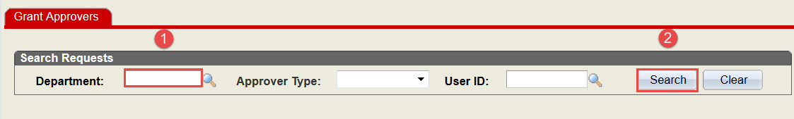
Navigation: Main Menu > Financial Systems > Contracts and Grants > Grant Approver.

    - Enter the desire search criteria (i.e., OUC).
      - Enter a 2, 4 or 6 Digit OUC.

Note: If a 6 digit OUC is entered and it returns No results, enter the 4 Digit OUC for the unit. This may mean during the initial setup of roles, your access was provided at a 4 digit level.

  - If you are a College Reviewer or Approver or have “designated” college level approvals (i.e., GBM Role) and need access to PMR – contact your Grant Business Officer (formerly, CBO or CRO)

  - If you are a Department Head or Designee and need access to PMR – contact your Grant Business Officer (formerly, CBO or CRO)
  - If you are the Grant Business Officer (GBO) or Designee and need access to PMR – Contact Thelia Burrell via phone at 919-515-8006 or via email at thelia_burrell@ncsu.edu.

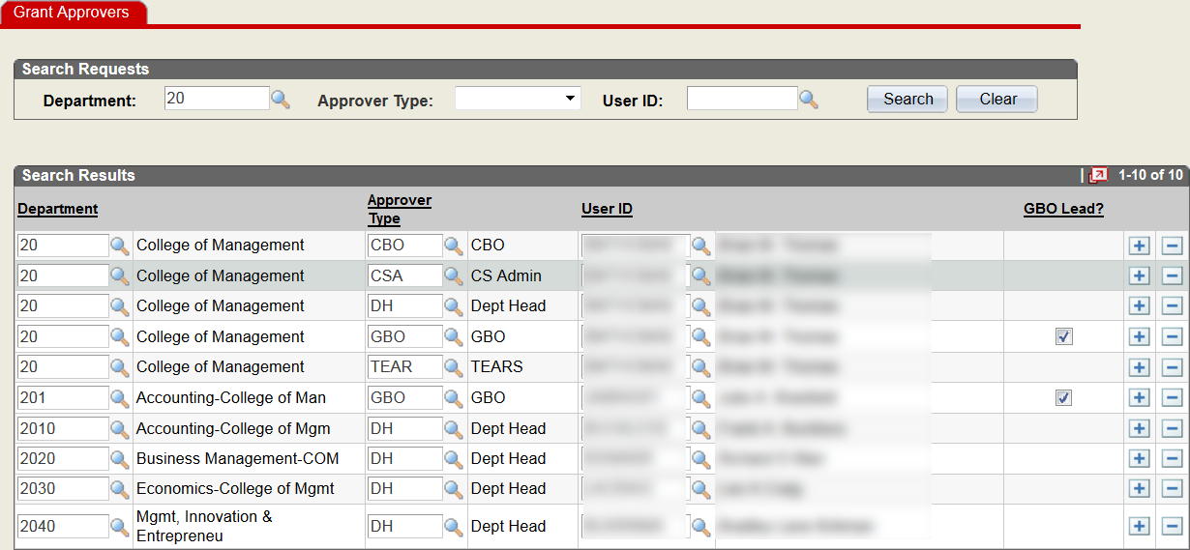

Who can initiate a Project Modification Request (PMR)?
A PMR can be initiated by the Principal Investigator (PI), or the department or college representative. Most PMRs follow a workflow similar to the one shown below:

Grant Business Manager (GBM)
Department Approver
OPTIONAL ROLE
Grant Business Officer
(GBO)

Department Head (DH)
Request specific

Grant Administrator (GADM)
Department Bookkeeper Contract Manager

Principal Investigator (PI)

SPARCS (SP)

Contracts & Grants (CG)

How to access the Project Modification Request System?
There are three (3) ways to access the Project Modification Request System:
- By navigating through the Financials Menu to the Project Modification Request menu item
Navigation: Main Menu > Financial Systems > Contracts and Grants > Project Modification Request
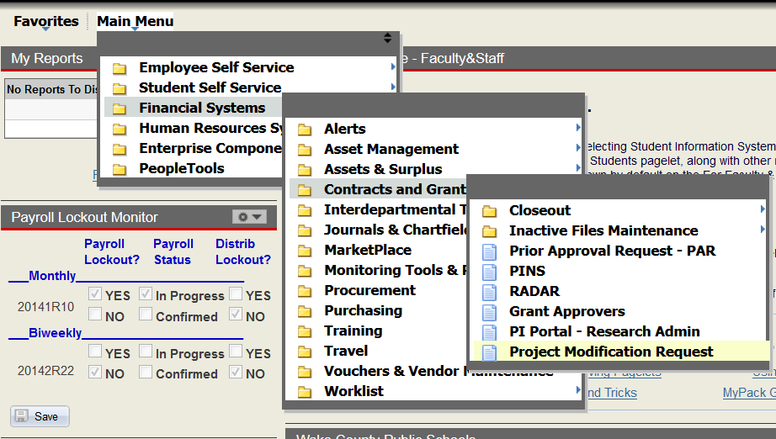
•
•
•
Note: A PMR approver will only receive an email notification, when a request has been submitted and routed to their specific role.

- By navigating to the Worklist:
This method will be especially beneficial for users with multiple approver roles.
Main Menu > Financial Systems > Worklist > Worklist
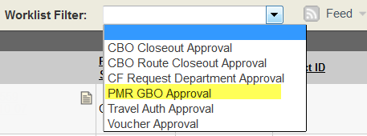

The user will be able to filter the work list to target the PMR actions requiring processing.

- By navigating to the Project Modification Request Module from the email notification
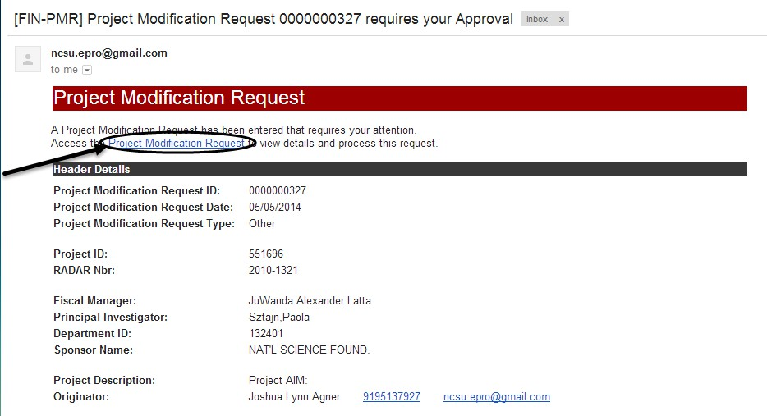

How to Initiate and Submit a Request
  - From the Project Modification Request (PMR) landing page, enter or search for the desired Project ID
  - Next, select the desired Request Type and press Add to begin the request process
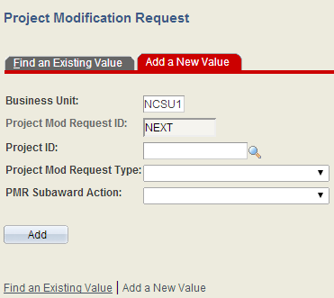

Note: For Subaward actions, you must also select the type of PMR Subaward Action:
    - Issue New
    - Modify or Terminate
This field will be greyed out for all other transaction types.

The Request Form is split into three (3) sections:
- HEADER SECTION – This section provides key information about the project. This information feeds from data entered by the Office of Contracts & Grants in the Project Maintenance section of financials.
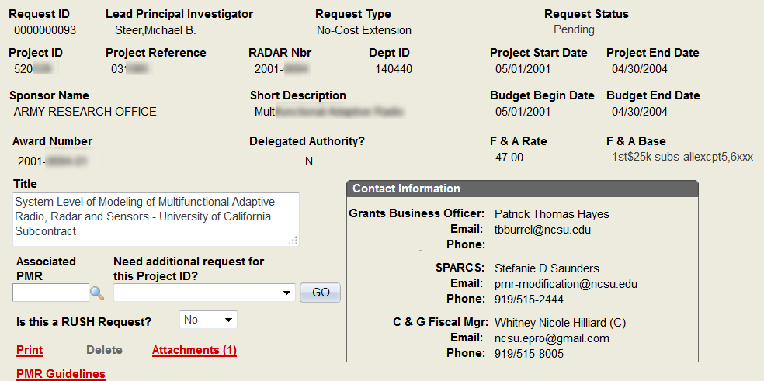

Header Field Descriptions:
Note: For attribute issues, please send an email to the assigned C&G Fiscal Manager and the cnghelpdesk@ncsu.edu. If the information is ALSO incorrect in RADAR, copy SPS@ncsu.edu on the email.
The Subject Line for email should say: Attribute Correction: then list the Project ID. The body of the email should include the Project ID, and a description of the attribute issue.

PI’s should notify their College Grant Business Officer of any issue.
The Fiscal Manager will review the request and make any necessary changes. This review process will be inserted into the normal daily duties, and processed as possible.
  - Request ID – This field provides the identifying PMR Number associated with the request. The request number increases based on the number of previous transactions for all projects and not the number of requests for this specific project. Numbering is sequential.

  - Lead Principal Investigator – The Lead PI listed for the Project, per feed from RADAR
  - Request Type – Indicates the type of request submitted for review and approval.
  - Request Status – The current status of the request. There are six
(6) status types.
- New – Request has been initiated, saved and PMR ID assigned. The request has not entered the approval process.

- Pending – Request has been entered and submitted for approval and processing. The request will remain in a “pending” status while routing through the various approvals until final approval provided.

- Denied – Request has been entered and submitted for approval and processing but was denied due to missing information, incomplete request.

- Waiting for Sponsor Response – Request has been entered and submitted for approval and processing. The request will remain in a “waiting for sponsor response” until agency approval is provided.
- Completed – Request has been entered and submitted for approval and processing. The request was final approved by C&G, SPARCS or the Asset Management Unit.

- Terminated – Request has been entered and submitted for approval and processing. The request was denied by the sponsor.
  - Project ID – Project ID associated with the request
  - Project Ref – Project Reference associated with the Project ID

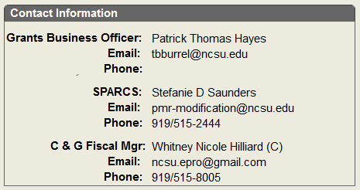
  - RADAR Nbr – Represents the Proposal Nbr.
The format is XXXX-XXXX.
  - Dept ID – Represents the OUC or Department Identification code.
  - Project Start Date – Project Start Date of Project ID
  - Project End Date – Project End Date of Project ID
  - Sponsor Name – The Sponsor Name
  - Short Description – Abbreviated version of the long description. This field may include agency name, or name of subcontractor.
  - Budget Begin Date – Budget Begin Date of Project ID
  - Budget End Date – Budget End Date of Project ID
  - Award Number – This is the Award No., Contract No. Agency Reference No.
  - Delegated Authority? – Yes / No check box. This information feeds from an attribute flag maintained by Contracts & Grants.
  - F&A Rate – The approved F&A rate
  - F&A Base – F&A Base. Translation values are as follows:
    - A – S&W (Salary & Wages)
    - B – MTDC (1st $25K – Subs, All Except 5, 6XXX)
    - C – Spec (Special)
    - D – TDC
  - Title – The Long Description

Contact Information Box:

    - Grants Business Officer – This field will default to lead GBO for the College or Unit. It will default to the person assigned the role for the 2 digit OUC associated with the project id. This section will also include the name, email address and phone number of the person identified as the Lead GBO for the college.

    - SPARCS – This field will default to the person assign the SPARCS Role. It will include the name, email address and phone number of the person assigned.
    - C&G Fiscal Manager & Code – This field will default to the person assign the C&G Role and Fiscal Manager Desk Code for the assigned project. It will include the name, email address, phone number and fiscal manager code.

Other features with the Header section:
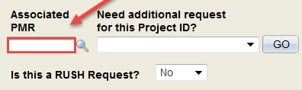
- Associated PMR field
  - If submitting multiple requests, this field can be used to link the requests together.

    - Usage of this field is necessary to ensure proper communication with the agency. Agency communications should include all necessary information to avoid multiple agency communications at a specific time.

    - This feature may only be used to link other requests that have a “Pending” status. The “Pending” status indicates the request has been routed for approval but the final approval has not been provided.

    - If submitting multiple requests, the user should link the requests in the following manner
      - The 2nd request should reference the 1st
      - The 3rd request should reference the 2nd, etc.

Note: This will create a “chain” showing the requests linked together

  - It is the GBO’s responsibility to ensure the Associated PMR field references the other request number.

  - It is the GBO’s responsibility to ensure the FIRST request has a note to indicate multiple requests are being submitted for review and processing.

“Need additional request for this Project ID?” field
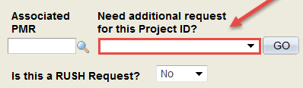

  - This field can be used to change the type of request to submit.
    - If the incorrect request type is selected from the main menu, the initiator does not have to navigate back to the main menu to select the correct request type. The initiator can change the request type from within the current request type.
  - This field should be used if multiple requests are needed for the same project. Once the initial request is submitted, the initiator must select the next type of request to submit.
    - Note: If a request is needed for a different project, the initiator must return to the main menu to begin the request process.

Is this a RUSH Request? field
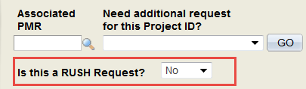

  - This field will default to “NO”
    - This field should ONLY be used to flag a request as a “RUSH” when the following criteria exist:
      - Approaching “Agency Imposed” deadline to submit the request
      - Risk of loss of funding
      - Risk of loss of award
      - Risk of audit finding
  - To flag a request as “RUSH” change the value to “YES”
  - If a request is deemed not a “rush” approvers within the workflow will have the ability to change the flag back to “NO”
  - The email notification for RUSH request will indicate this status within the body of the request.
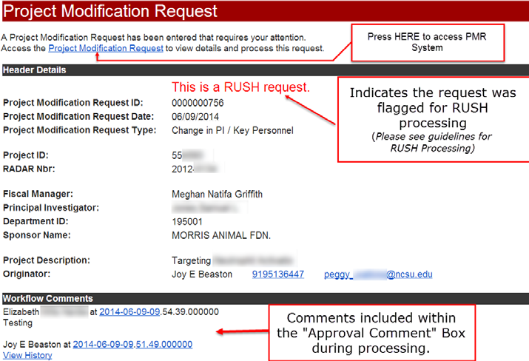

- Print hyperlink
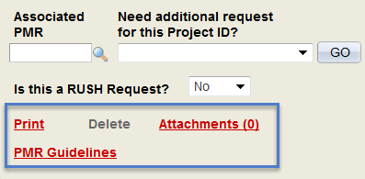
  - This hyperlink can be used to produce a PDF copy of the request.

Note: It is highly recommended campus users print a copy of the completed PMR. A copy should be maintained in the departmental file.
- Attachments (0) hyperlink
  - This hyperlink can be used to attach documents.
  - The number within the parenthesis ( ) indicates
the number of files attached to the request.
    - Acceptable file types
      - Adobe (.pdf)
      - MS Word (.doc or .docx)
      - MS Excel (.xls or .xlsx)
      - Txt Files
  - Note: Please make sure the file name is clear to ALL users.
For example: If attaching the Vita for the PI, the file name should be john_doe_vita.doc.
- Delete hyperlink
  - A hyperlink will appear when the request is at the Initiator’s level. It will allow the initiator to delete any requests they have submitted that have a current a status of “Pending”.
Note: You cannot delete a request with a current status of “completed.”

  - The request will be permanently removed from the PMR Search and Main Menu.
  - The Request Id number will not be available for re-use.
- PMR Guidelines hyperlink
  - This hyperlink will transfer the user to the PMR section of the Office of Contracts & Grants website (http://C&G.ncsu.edu/systems/pmr)

- REQUEST SECTION – This section is specific to the type of request selected. The questions and information provided are particularly important to submit the request and obtain agency approval.
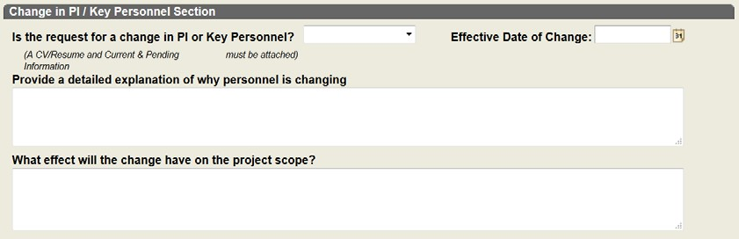
  - The initiator should answer the questions within the request and upload all required documentation to support the request.
  - If the user is not ready to submit the request for processing and approval, the request can be saved.

To save a “draft copy” of your request:
  - Enter request information
  - Press the button

A PMR Request ID will be generated. The Request Status will remain as “New” until the request is routed for approval.
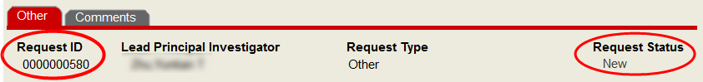

To submit a request for approval:
  - Press the button
  - The workflow will be initiated and the request will be routed to the next level for approval.

- APPROVAL SECTION – This section will outline the route a request must “travel” to obtain final approval. It will also indicate where other approvals have been inserted within the workflow approval process.
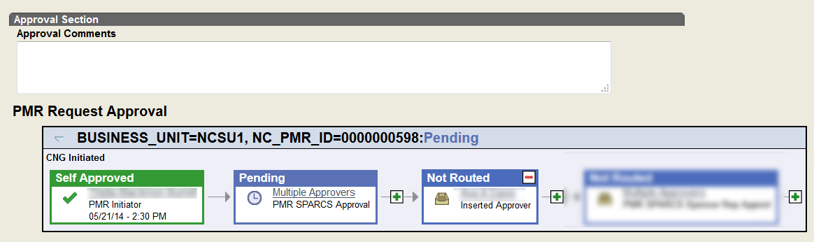

This section will also include any comments entered in the “Approval Comment” box. The comments could be necessary information for approvers to make the final decision.
Note: Comments entered within the Approval Comment box will be included within the email notifications.

Routing of Project Modification Requests
A request can be initiated by the Principal Investigator, staff within the Department or College Research Office. Depending on the college approval requirements, a request initiated by the Principal Investigator, or Grant Administrator must be approved by both the Grant Business Manager and Grant Business Officer or just the Grant Business Officer prior to routing to Contracts & Grants or SPARCS. The required approvals are contingent upon approval setups.

Listed below are the workflows by request type:

BUDGET MODIFICATION – ROUTES TO C&G FOR FINAL APPROVAL
INITIATOR | APPROVAL ROUTING |  |  |  | FINAL APPROVAL EMAIL NOTIFICATION RECIPIENTS
PI | GADM | GBM | GBO | C&G | NOT APPLICABLE
GADM | GBM | GBO | C&G |  | NOT APPLICABLE
GBM | GBO | C&G |  |  | NOT APPLICABLE
GBO | C&G |  |  |  | NOT APPLICABLE

CARRYOVER/CARRY FORWARD – ROUTES TO SPARCS FOR FINAL APPROVAL
INITIATOR | APPROVAL ROUTING |  |  |  | FINAL APPROVAL EMAIL NOTIFICATION  RECIPIENTS
PI | GADM | GBM | GBO | SPARCS | - Initiator  - All GBOs for Assigned Dept ID  - C&G Fiscal Manager
GADM | GBM | GBO | SPARCS
GBM | GBO | SPARCS
GBO | SPARCS

CHANGE IN PI – ROUTES TO SPARCS FOR FINAL APPROVAL
INITIATOR | APPROVAL ROUTING |  |  |  |  | FINAL APPROVAL EMAIL NOTIFICATION  RECIPIENTS
PI | GADM | GBM | DH | GBO | SPARCS | - Initiator  - All GBOs for Assigned Dept ID  - C&G Fiscal Manager
GADM | GBM | DH | GBO | SPARCS
GBM | DH | GBO | SPARCS
GBO | SPARCS

CHANGE IN SCOPE – ROUTES TO SPARCS FOR FINAL APPROVAL
INITIATOR | APPROVAL ROUTING |  |  |  | FINAL APPROVAL EMAIL NOTIFICATION  RECIPIENTS
PI | GADM | GBM | GBO | SPARCS | - Initiator  - All GBOs for Assigned Dept ID  - Department Head  - C&G Fiscal Manager
GADM | GBM | GBO | SPARCS
GBM | GBO | SPARCS
GBO | SPARCS

EQUIPMENT ACQUISITION – ROUTES TO C&G FOR FINAL APPROVAL
INITIATOR | APPROVAL ROUTING |  |  |  |  | FINAL APPROVAL EMAIL NOTIFICATION  RECIPIENTS
PI | GADM | GBM | DH | GBO | C&G | - Initiator  - All GBOs for Assigned Dept ID  - SPARCS
GADM | GBM | DH | GBO | C&G |  | - Initiator  - All GBOs for Assigned Dept ID  - SPARCS
GBM | DH | GBO | C&G |  |  | - Initiator  - All GBOs for Assigned Dept ID  - SPARCS
GBO | C&G |  |  |  |  | - Initiator  - All GBOs for Assigned Dept ID  - SPARCS

FABRICATED EQUIPMENT – ROUTES TO ASSET MGT FOR FINAL APPROVAL
INITIATOR | APPROVAL ROUTING |  |  |  | FINAL APPROVAL EMAIL NOTIFICATION  RECIPIENTS
PI | GADM | GBM | GBO | AM | - Initiator  - All GBOs for Assigned Dept ID  - Department Head  - C&G Fiscal Manager
GADM | GBM | GBO | AM
GBM | GBO | AM
GBO | AM

NO COST EXTENSTION (1st/2nd Request) – ROUTES TO SPARCS FOR FINAL APPROVAL
INITIATOR | APPROVAL ROUTING |  |  |  | FINAL APPROVAL EMAIL NOTIFICATION  RECIPIENTS
PI | GADM | GBM | GBO | SPARCS | - Initiator  - All GBOs for Assigned Dept ID  - C&G Fiscal Manager
GADM | GBM | GBO | SPARCS
GBM | GBO | SPARCS
GBO | SPARCS

PREAWARD COST (<=90/>90 DAYS) – ROUTES TO SPARCS FOR FINAL APPROVAL
INITIATOR | APPROVAL ROUTING |  |  |  | FINAL APPROVAL EMAIL NOTIFICATION  RECIPIENTS
PI | GADM | GBM | GBO | SPARCS | - Initiator  - All GBOs for Assigned Dept ID  - C&G Fiscal Manager
GADM | GBM | GBO | SPARCS
GBM | GBO | SPARCS
GBO | SPARCS

SUBAWARD MODIFICATION – ROUTES TO SPARCS FOR FINAL APPROVAL
INITIATOR | APPROVAL ROUTING |  |  |  | FINAL APPROVAL EMAIL NOTIFICATION  RECIPIENTS
PI | GADM | GBM | GBO | SPARCS | - Initiator  - All GBOs for Assigned Dept ID  - C&G Fiscal Manager
GADM | GBM | GBO | SPARCS
GBM | GBO | SPARCS
GBO | SPARCS

OTHER – ROUTES TO C&G FOR FINAL APPROVAL
INITIATOR | APPROVAL ROUTING |  |  |  | FINAL APPROVAL EMAIL NOTIFICATION  RECIPIENTS
PI | GADM | GBM | GBO | C&G | Not applicable
GADM | GBM | GBO | C&G |  | Not applicable
GBM | GBO | C&G |  |  | Not applicable
GBO | C&G |  |  |  | Not applicable

TRAVEL (DOMESTIC / FOREIGN) – ROUTES TO SPARCS FOR FINAL APPROVAL
INITIATOR | APPROVAL ROUTING |  |  |  | FINAL APPROVAL EMAIL NOTIFICATION  RECIPIENTS
PI | GADM | GBM | GBO | C&G | - Initiator  - All GBOs for Assigned Dept ID  - SPARCS
GADM | GBM | GBO | C&G |  | - Initiator  - All GBOs for Assigned Dept ID  - SPARCS
GBM | GBO | C&G |  |  | - Initiator  - All GBOs for Assigned Dept ID  - SPARCS
GBO | C&G |  |  |  | - Initiator  - All GBOs for Assigned Dept ID  - SPARCS

PMR Role Definitions:
- PI: Principal Investigator - This role may initiate requests. When this role initiates the request, there will be no prior routing history and will be listed as the PMR Initiator.
- PMR GADM: This role is for the Grant Administrator. This role is similar to Departmental Bookkeeper, or Contract Manager. Person(s) who potentially works for/reports to a GBO or GBM. This role may initiate requests.

When this role initiates the request, there will be no prior routing history and will be listed as the PMR Initiator.
- PMR DH: This role is for the Department Head or Designee functioning as the Department Head. This role may initiate requests. When this role initiates the request, there will be no prior routing history and will be listed as the PMR Initiator.
- PMR GBM: This role is for the Grant Business Manager. This role has limited college level approval or is responsible for review and approval of the GADM work. Person(s) who potentially works for/reports to a GBO. This role is responsible for ensuring all necessary internal approvals, documentation, and information is received and include prior to routing to the GBO. This role may initiate requests. When this role initiates the request, there will be no prior routing history and will be listed as the PMR Initiator.
- PMR GBO: This role is for the Grant Business Officer. This role was formerly called the College Business Officer (CBO) or College Research Officer (CRO).
This is the final level of approval prior to routing to Contracts & Grants or SPARCS. This role is responsible for ensuring all necessary internal approvals, documentation, and information is included with the request. This role is also responsible for ensuring the requests meet the University, State, and Agency Guidelines prior to approving request. This role may initiate requests. When this role initiates the request, there will be no prior routing history and will be listed as the PMR Initiator.

- PMR FM: This role is for the C&G Fiscal Manager assigned to this project. This role is responsible for ensuring University, State and Agency Guidelines are followed when deciding whether to approve or deny a request. The approval or denial at this level is contingent upon prior approvals ensuring the request is complete prior to submitting for final approval. This role may initiate requests. When this role initiates the request, there will be no prior routing history and will be listed as the PMR Initiator.

- PMR AM: This is the Asset Management Unit. This role is responsible for the review of all Fabricated Equipment requests. These requests will not route to C&G or SPARCS for approval. The Asset Management unit within the Controller’s Office will provide the final input regarding these requests.

- PMR SPARCS. This role is for the Office of Sponsored Programs staff (SPARCS). There are three (3) specifics roles with SPARCS. This role is responsible for ensuring University, State and Agency Guidelines are adhered to when deciding whether to approve or deny a request. The approval or denial at this level is contingent upon prior approvals ensuring the request is complete prior to submitting for final approval
  - PMR Approval: This is the “Triage” area for requests routed to SPARCS for final approval. This role determines if a PMR needs to go to the other SPARCS levels for review and approval/denial or processing.

  - The other SPARCS roles are:
    - PMR SPARCS Processor:
    - PMR SPARCS Negotiator:
    - PMR SPARCS Sponsor Approval:

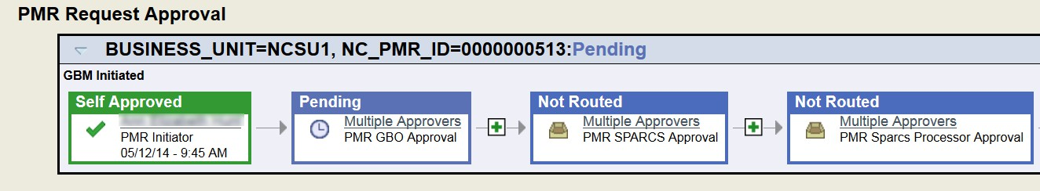
- When a request is routed for approval, the designed workflow will appear in the PMR Request Approval box.
Note: The Workflow will NOT display until the actual workflow is initiated through the submit function.

- The workflow will display a box for each role from the initiator through the final approver.

- If specific approval roles have not been selected for your Departmental ID, the role will show as Skipped in the workflow.

- If there is only one approver for a designated area, the approvers name will be displayed within the approval box.

Approval Box Definitions:
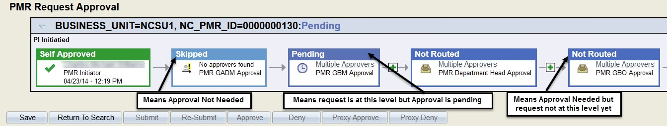
- If there are multiple approvers for a designated area, “Multiple Approvers” will be displayed within the approval box.

- When a request is initiated and submitted the initiator’s box will turn “Green” and the words “Self Approved” will be displayed on top of box. The box will display the initiators name, date and time submitted.

- When a request is approved, the box will be “Green” and the word “Approved” will be displayed on top of box. The box will display the approver’s name, date and time approved.
- When a request has been routed for approval, but the approval is pending, the box will be “Blue” and the word “Pending” will be displayed on top of box.
- When a request has not been routed for approval, but a future approval is required, the future approval box will be “Blue” and the words “Not Routed” will be displayed at the top of the box. This indicates the approval is needed but the request is not at that level yet.
- When a request has been routed for approval, but a future approval box is not needed, the future approval box will be “Light Blue” and the word “Skipped” will be displayed at the top of the box. This indicates the approval is NOT needed.
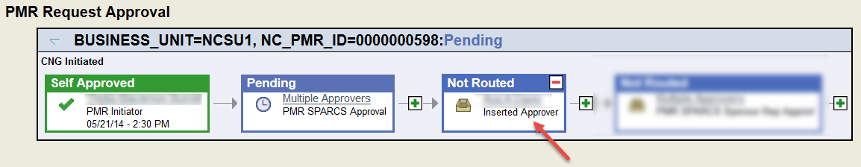

Adhoc Approvals:
- The initiator or approver can insert additional approvers or reviewers only after the workflow has been initiated.
- An Adhoc approvers or reviewers can be inserted at any point within the approval routing processes.

Note: An email will be generated when the user inserts an Adhoc Approver or Reviewer within the workflow routing.
  - When the user inserts an Adhoc Approver, the request will appear on the Worklist.
  - When the user inserts an Adhoc Reviewer, the request will NOT appear on the Worklist.
  - When trying to insert an approver between the current and next approver, timing is an important factor.

Adhoc Approver/Reviewer Rules:
- When written approval from other colleges is NEEDED:
  - If a request is submitted by a college and the transaction will impact another college(s), the initiating college is required to Adhoc at least the Lead GBO for all of the other impacted colleges. The GBO should be inserted as an APPROVER. This will ensure all necessary approvals are received and properly documented.
  - When Adhoc Approver has been inserted within the workflow, that approval is REQUIRED to move the request forward to the next level.

When written approval from other colleges is ALREADY received:

  - If a request is submitted by a college and the transaction will impact another college(s), the initiating college is required to Adhoc at least the Lead GBO for all of the other impacted colleges. The GBO should be inserted as a REVIEWER. This will ensure all necessary notifications are received and properly documented.
  - When Adhoc Reviewer is inserted within the workflow, their approval is NOT required to move the request forward to the next level.

To add an Adhoc Approver or Reviewer:
- From within the Approval Section of the request,
  - Press the + to insert an approver or reviewer within the already initiated workflow.
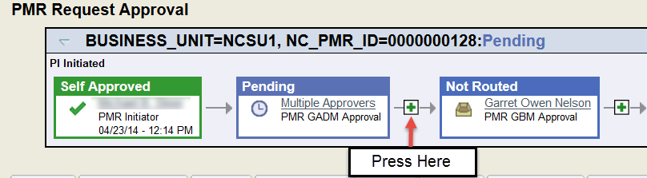

  - If the PMR Approver needs to insert an additional approver prior to the next approval level, the Adhoc Approver must be inserted and workflow change saved prior to pressing the Approve button.

  - An “Insert additional approver or reviewer” sub –window will appear

    - If the person’s Unity ID is known,
      - Enter the Unity ID of the desired approver or reviewer in the User ID: field

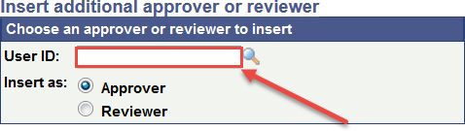
•
•
•
•

      - ID MUST be entered in All CAPS

- If Unity ID is NOT known,
  - Press the magnifying glass to search using the name



  - Enter a portion of the user name or ID
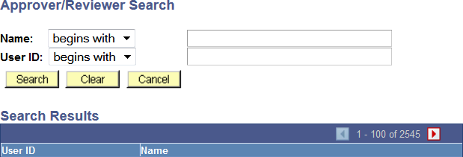

  - Press Search button
  - Locate desired name in search results list
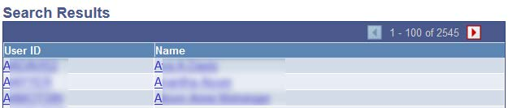

  - Press hyperlink for desired name
    - User ID will be automatically transferred the “Insert additional approver or reviewer” sub-window

  - Select desired Adhoc Role
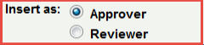

Adhoc Role Definitions:
- Inserted Approver: This role is for the Adhoc Approvers inserted within the workflow of the request. The Adhoc functionality can be used to request approval from other colleges or personnel not already within the designed workflow.

    - Reviewer: This role is for the Adhoc Reviewer inserted within the workflow of the request. The Adhoc functionality can be used to copy another colleges or personnel not already within the designed workflow
  - Press Insert button

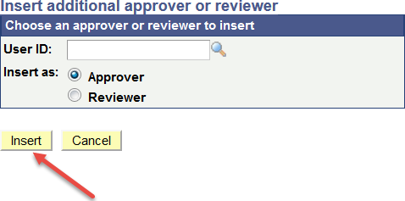
YOU MUST SAVE THE WORKFLOW CHANGES OR CHANGES WILL NOT SAVE AND YOU WILL HAVE TO REPEAT THESE STEPS.

  - To SAVE WORKFLOW CHANGE press the button

Note: The ability to specifically insert another College GBO prior to the initiator’s GBO depends on the initiator’s PMR Role and whether their requests will route directly to the GBO.

For example, if the initiator is the GBM, the request when submitted will route directly to the GBO. Therefore, the initiator will not be able to insert the other college GBO prior to their GBO. Thus meaning, the other college GBO approval must be obtained out of PMR.

If the initiator’s request will route for an additional prior to their GBO, the initiator will be able to insert the other college GBO prior to their GBO.

TO SEARCH FOR A REQUEST

From the Find Existing Value tab, enter the desired search criteria.
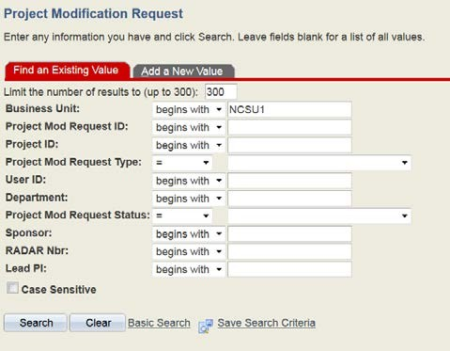

This search screen will provide the user information about all PMR’s currently in the system, regardless of assigned OUC.
However, users will only be able to take action on PMR’s they have approval authority or OUC access.
PMR’s in another department OUC will be accessible but the user will not be able to make changes to the request.

There are multiple ways to search for the desired information. On the desired search line, select one of the following qualifiers for the search:
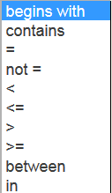
Note: When searching for a request and only a portion of the request information is available, enter the desired search, change the search qualifier (using the dropdown) from  to .
Using the entered criteria, the system will search for that information anywhere within the selected field.
For example, if searching for any requests with the #19, the list will present: 000000019, 000000819, 000010219, 000010819, etc.

SEARCH RESULTS
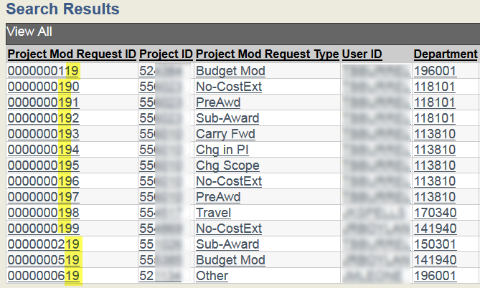
The search result will provide basic information about all requests that have been entered into PMR and had a request id assigned.
Note: a Request ID is assigned when a request is entered and saved or submitted for review and approval.

Information included within the search results:
Request ID, Project ID, Request Type, User ID (initiator), Dept ID, Request Status, Sponsor, Radar Nbr, Lead PI Name, and whether a request has been marked as a RUSH.

WORKLIST

The worklist can be used to locate previously submitted requests pending approval, denied or request where you as the user have been inserted as an Adhoc Approver.
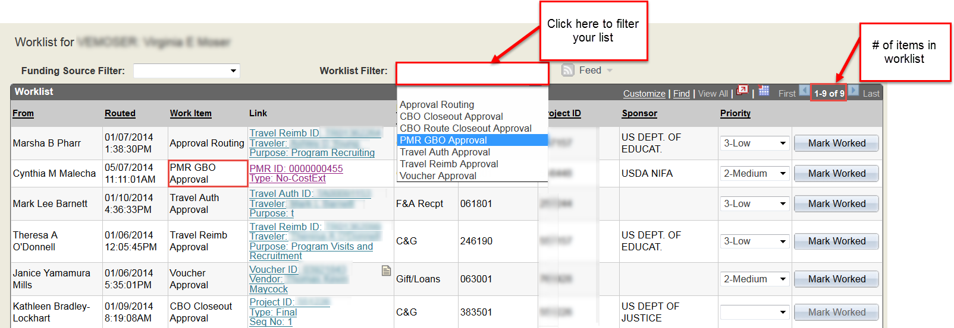
When the Worklist Filter is used to narrow the list, it will remove all items that do not meet the selected criteria.
For example, the image above shows 9 items on the worklist. After the Worklist Filter is used, the number of items on the worklist decrease to one (1) item (see image below).

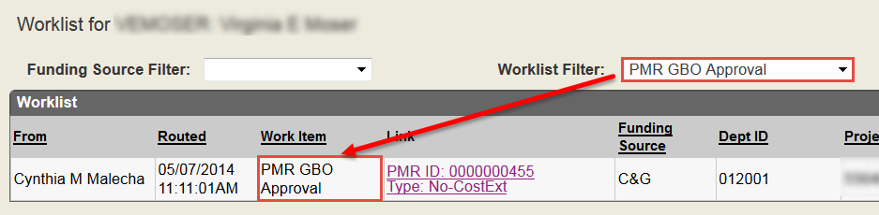
Worklist Filters:
- PMR GADM Approval – Request submitted by PI awaiting GADM approval.
- PMR GBM Approval – Request submitted or approved by GADM awaiting GBM approval.
- PMR Department Head Approval – A Change of PI or Equipment Acquisition request awaiting Department Head approval.
- PMR GBO Approval – Requested submitted or approved by GADM (if no GBM role), GBM (if applicable), DH (if applicable) awaiting GBO approval.
- PMR Fiscal Manager – Request awaiting C&G review and approval.
- PMR SPARCS Approval – Request awaiting initial review and approval routing by SPARCS Staff. This is the “Triage” period where additional approvals are designated.
- PMR SPARCS Processor – Request awaiting review and approval by a SPARCS Processor. This approval is designated during the SPARCS Approval review.
- PMR SPARCS Negotiator – Request awaiting review and approval by a SPARCS Negotiator. This approval is designated during the SPARCS Approval review.
- PMR SPARCS Sponsor Rep Approval – Request approved by SPARCS staff but awaiting final approval from agency. This approval is designated during the SPARCS Approval review.

- Transaction Denied – Request denied by C&G, SPARCS, or Asset Management. Request denied due to incomplete or incorrect information.

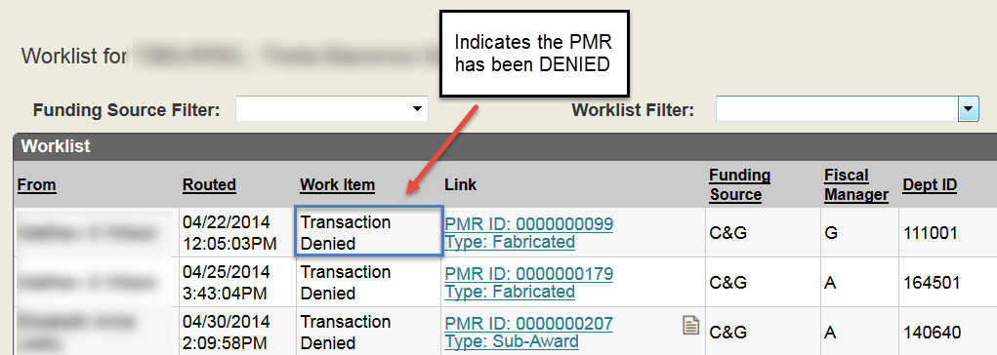

- Approval Routing – Request routed for approval as an Adhoc Approver.
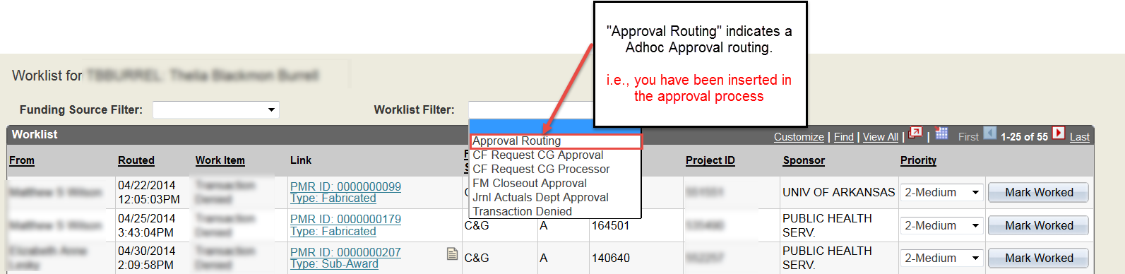

DENIED REQUEST

When a request is deemed to have incomplete or incorrect information, the request can be denied.
An email notification will be generated indicating the request has been denied. Any comments entered in the Approval Comment box regarding the denial will be capture within the box of the email notification.

A denied request will be returned directly to the Initiator. The initiator will have the ability to correct the request and Resubmit for approval. The resubmit button will be available at the Initiator’s level.
The Initiator’s GBO for the project will be copied on the denial email notification. This is for information purposes only. The GBO will not be able to work the request.

The status of the request will change to “Denied”

When a request is denied due to incomplete or incorrect information, the necessary adjustment can be made and the request resubmitted.
When a request is resubmitted, it will go through the entire approval routing process.
Note: If Adhoc approvers or reviewers were added to the original request, they must be manually reinserted in the approval routing process.

IT IS IMPERIATIVE WHEN A REQUEST IS BEING DENIED DUE TO INCORRECT OR INCOMPLETE INFORMATION THE CORRECT DENIAL BUTTON IS PRESSED.
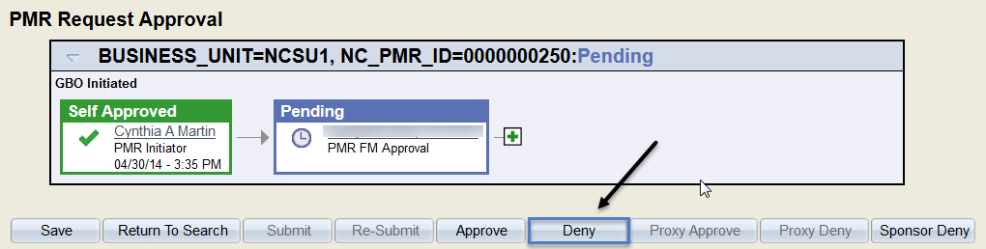
Note: The Sponsor Deny button is only available to C&G and SPARCS staff

SPONSOR DENIAL – NO RESUBMIT
When a request is denied due to sponsor denial, the denied request will be returned directly to the Initiator.
The initiator will NOT have the ability to make changes and resubmit the request.
An email notification will be generated indicating the request has been denied. Any comments entered in the Approval Comment box regarding the denial will be capture within the box of the email notification.
The resubmit button will not be available.
The Initiator’s GBO for the project will be copied on the denial email notification.

This is for information purposes.
The status of the request will change to “Terminated”
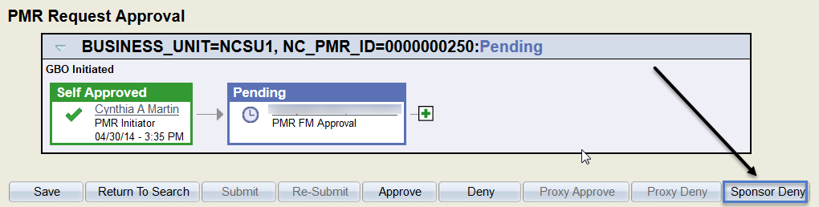

Note - For Denied and Sponsor Denial Requests:
A detailed justification should be included in the Approval Comment section justifying the denial.
This is strongly recommended for all Campus Approver Denials and C&G or SPARCS denials (i.e., denied request and sponsor denials).

PROXY APPROVAL & PROXY DENY – For C&G ONLY

The Proxy Approval and Deny buttons will only be available to designated C&G Managers.
When a request is routed to C&G, the assigned Fiscal Manager will be able to process the request. However, in the absence of the assigned C&G Fiscal Manager, members of the upper management team will have access to process the request using the Proxy Approval & Proxy Deny function.

The Proxy Approval and Deny buttons will be available to the following C&G staff:
- Director,
- Asst. Directors (2)
- Assoc. Director,
- Systems Accountant, and
- Senior Fiscal Managers (3)

To proxy approve/deny a request:
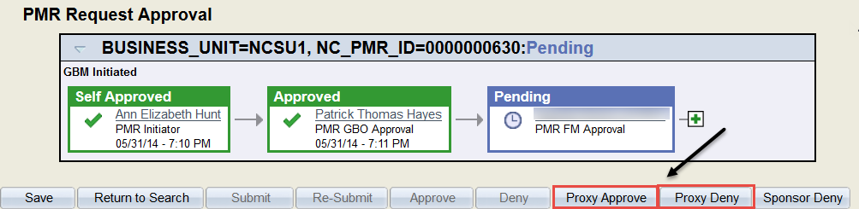
- Press the Proxy Approve or Proxy Deny button

Note (1):
If Adhoc Approver or Reviewer is needed, this must be inserted PRIOR to the proxy approval/denial.

Note (2) - For Proxy Denied Requests:
A detailed justification should be included in the Approval Comment section justifying the denial.

COMMENTS TAB

The Comments Tab is available for the user to include comments or information regarding the request. It may also be used to relay information to assist with the approval process.
The name of the person inserting the comment, and the date and time the comment is inserted will be display above each comment entered.
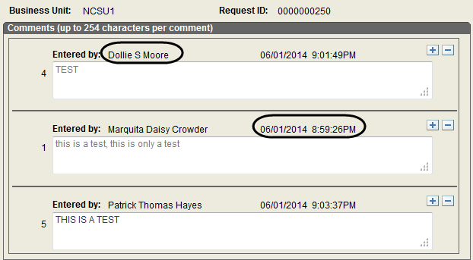

To add a comment:

- Press the + and add comment to comment box.

Note: comment box is limited to 254 characters.

To remove a comment:
- Press the – on the desired box.
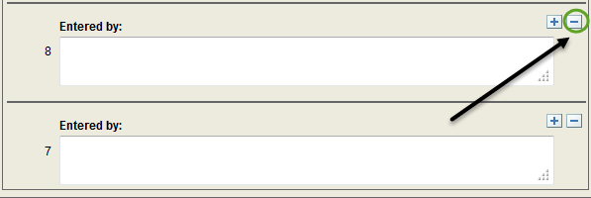

If a comment needs to be removed from a request, only the initiator of the comment can remove it.

General PMR Processing Notes
Project Modification Requests requiring C&G approval will “generally” be processed in the PMR system within four (4) business days of receipt of the request.

Project Modification Requests requiring SPARCS approval will “generally” be processed within the PMR system within seven (7) business days of receipt of the request.
Note: The extended processing time in SPARCS is to account for the processing of any requests originally sent to directly C&G that also require additional processing by SPARCS.

If a request is denied and resubmitted, the processing timeframe clock will begin again. The clock will begin when the request is routed back to the appropriate Central Office (i.e., C&G or SPARCS).

Follow-up Process for PMR

The follow-up process for Project Modification requests submitted to the sponsor for approval will be as follows:
- Initial follow-up should occur 30 calendar days after the date the request is submitted to the sponsoring agency
  - Follow-up will include sending an email to the appropriate agency Program or Granting Officer.

  - The Grant Business Officer (GBO) should be copied on this email communication.

  - Notes / a summary of the conversation(s) with the sponsoring agency will be added to the Comments Tab.
    - The actions necessary to obtain agency approval will be handled by the appropriate Central Office (i.e., C&G, or SPARCS).
- Secondary follow-up should occur 10 business days from the initial follow-up.
  - Follow-up will include contacting the appropriate agency Program or Granting Officer by phone.

  - Notes / a summary of the conversation(s) with the sponsoring agency will be added to the Comments Tab.
    - The actions necessary to obtain agency approval will be handled by the appropriate Central Office (i.e., C&G, or SPARCS).
- Third follow-up should occur 5 business days from the secondary follow-up.
  - Follow-up will include notifying the Grant Business Officer of the agency’s unresponsiveness and request assistance.

  - Notes or a summary of the conversation(s) with the sponsoring agency will be added to the Comments Tab.
    - The actions necessary to obtain agency approval will be handled by the appropriate Central Office (i.e., C&G, or SPARCS).

Multiple College Approvals:

When a request is submitted that impacts multiple colleges, it is the responsibility of the GBO to ensure ALL necessary approvals have been obtained prior to submitting the request.

If the request being submitted impacts another PI’s project (i.e., Lead PI), the GBO for the college submitting the request MUST ensure approval is obtained from the Lead PI or designee (i.e., GBO) for the other college. This should be a written approval.

Written approval can be provided in two (2) ways:
- Uploaded Document with the PI or Designees’ approval
- Via the Adhoc process – Adhoc to the GBO
  - It is the GBO’s responsibility to ensure the PI’s approval is received and maintained within their department files.

Missing “Other” College Approvals:

When a request is received without the “other” college(s) approval (i.e., multiple colleges), C&G and SPARCS staff will Adhoc the missing GBO(s).
It is the responsibility of the Adhoc GBO(s) to ensure the appropriate Fiscal Manager has been Adhoc after their approval. This is to ensure the request is returned for final review and approval.

REQUEST SPECIFIC SECTION

PROJECT MODIFICATION APPROVALS:
Awards for sponsored projects are issued to the identified grantee or contractor via an award document; SPARCS/C&G is designated as the institutional representative, to serve as the intermediary between the sponsor and the PI when implementing any changes in the project that require institutional and sponsor approval (such as changes in the scope of work, senior personnel, budget, and other modifications of award terms and conditions). When sponsor prior approval is required, the user should initiate a Project Modification Request (PMR) describing the desired change, with justification, and forward it to SPARCS/C&G for review and endorsement and submission to the sponsor.

Budget Modification
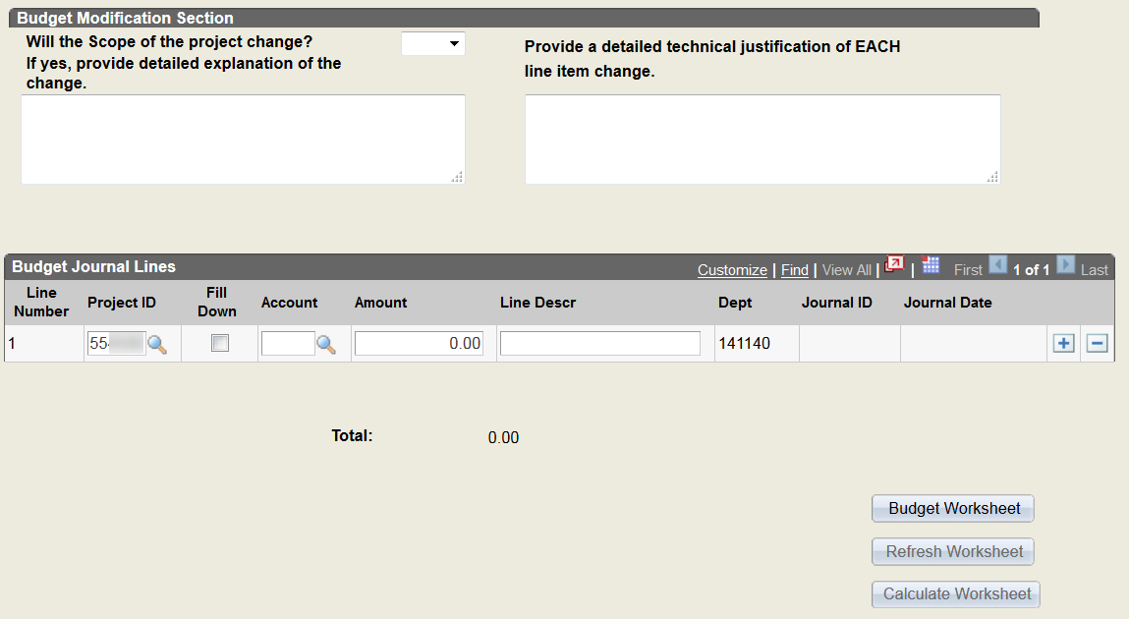
The Budget is the financial expression of the project or program as approved during the award process. It is not uncommon for a PI to determine that for efficient performance of the project, he/she must re-budget funds from one budget line or category to another.

Some sponsors have delegated this authority to the University to approve these type of changes or modifications.

Some sponsors require the University to formally submit a budget modification with an explanation of the need and the anticipated impact, if any, on the conduct of the work.
The justification should describe how the proposed budget modification will affect the technical purpose or scope of the project; contain a brief explanation of why the proposed budget modification was not planned originally, why other budgeted funds are now available for this purpose and the intended use of the funds.
A Budget Modification request may be submitted to realign the funds within specific budget categories. This type of modification may require agency approval.
A Budget Modification request may be submitted to move funds within Project Segments. Funds may only be moved to projects mapping to the Same Project Reference. The allowable list of projects can be found by pressing the magnifying glass.
When the magnifying glass is pressed, the approved list of projects will be displayed (i.e., projects mapping to same project reference).
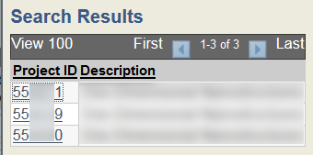
The Grant Business Officer is responsible for ensuring Budget Modification requests are not submitted within the last month of the project, unless an extenuating circumstance exist.
Note: When the request is submitted within the last month of the project, the Grant Business Officer MUST provide written approval (via upload or comment) of the extenuating circumstance. An example of the required approval statement is: “I, Jane Doe, Grant Business Officer authorize the submission of this request due to …”
- The Worksheet information is as of the previous night

Note: The use of the worksheet is totally optional. This is an additional resource but not required to use.

- The worksheet information will NOT print via the Print hyperlink
- If the worksheet information is used to create the journal line, the worksheet information should be printed and kept in the file for future reference.
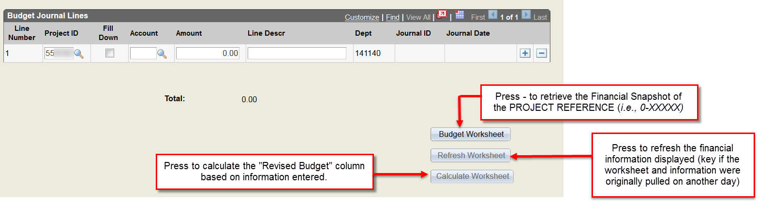

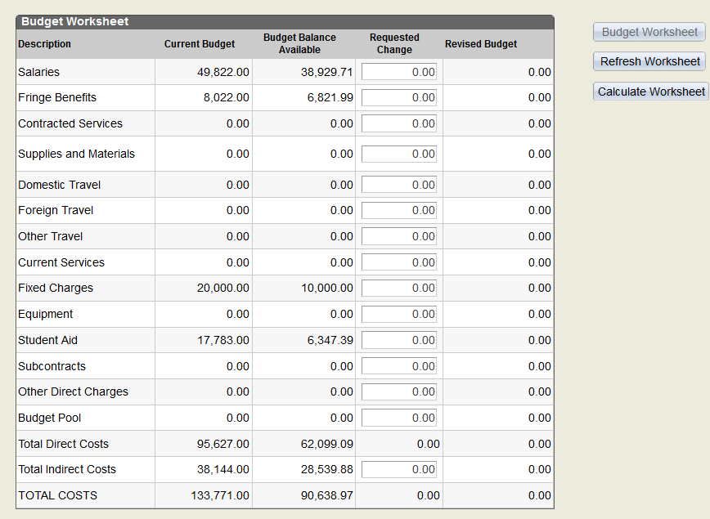
- Press Budget Worksheet button to retrieve financial snapshot of the selected Project Segment (i.e., Project ID selected for PMR Request).
- Press Refresh Worksheet button to reload financial snapshot information. This is essential if the information displayed was pulled prior to today. This will reload with information as of the previous night.
- The Calculate Worksheet button will calculate the Revised Budget based on (Current Budget) +/- (Requested Change)
- The Budget Balance column = Current Budget – Expenditures. The Budget Balance Available DOES NOT include encumbrances.

Important items to remember:
- The Budget Modification request should NOT be used to circumvent current procedures as it relates to Participant Support Cost (PSC), Research Experience for Undergraduates (REUs) or special / restricted funding.
- Information entered within the worksheet will NOT automatically transfer to the journal
- Information entered within the journal will NOT automatically transfer to the worksheet.
- The Worksheet will display a financial snapshot of the entire project.

Budget Correction:
A Budget Correction may be needed if the original budget is loaded incorrectly due to a misinterpretation of the budget categories based on the agency approved budget or due to a keying error.
A Budget Modification request, requesting a correction to the budget may be submitted within the first 90 days from the date the Project ID is set-up. This type of request may be submitted in two ways:

- Through the PMR system as a Budget Modification Request

The Justification MUST indicate the request is a Budget Correction.

- By email to the Fiscal Manager.

The email must indicate the specific change necessary to correct the budget categories.
All requests submitted 91+ days after the date the Project ID is set-up will be subject to the general rules for the processing a Budget Modification Request.

All correction requests are subject to a final review of the agency approved budget and approval by C&G.

Adhoc Rules for Budget Modification Request:
When a Budget Modification request is entered that will impact project(s) within another college, it is the responsibility of the Initiator, Departmental Approvers, and Grant Business Officer to ensure the necessary approvals are obtained from the other college.
If the approval is obtained prior to submitting the request, the written approval must be uploaded to the request.
If the necessary approvals have not been obtained, the Initiator must ensure the other college’s GBO is inserted as an Adhoc Approver or Reviewer.

Note:
The ability to specifically insert another College GBO prior to the initiator’s GBO depends on the initiator’s PMR Role and whether their requests will route directly to the GBO.
For example, if the initiator is the GBM, the request when submitted will route directly to the GBO. Therefore, the initiator will not be able to insert the other college GBO prior to their GBO. Thus meaning, the other college GBO approval must be obtained out of PMR.
If the initiator’s request needs to route for an additional approval prior to their GBO, the initiator will be able to insert the other college GBO prior to their GBO. This is contingent upon the workflow and position of the desired additional approval.

Note:

Budget Modification should NOT be used to request a transfer of remaining funds from an REU (Research Experience for Undergraduates) or PSC (Participant Support Cost) Segment back to the Prime.

ACCOUNT CODE LISTING

BUDGET BY “SUMMARY” ACCOUNT STRUCTURE - CALS, COS, CVM, COD, CNR, AND RESEARCH & GRAD STUDIES

1000 | Salaries
1800 | Fringe
1990 | Contracted Services
2000 | Supplies
3000 | Current Services
3100 | Domestic Travel
3130 | Foreign Travel
4000 | Fixed Costs
5000 | Equipment
6000 | Tuition
6980 | Subawards
8960 | Facilities & Administrative Costs (Indirect)

BUDGET BY “DETAILED” ACCOUNT STRUCTURE - COE, COT, EDUC, AND CHASS

1112 | Salary - Graduate Research Assistant
1116 | Salary - Summer Faculty Support
1118 | Salary - Release Time
1119 | Salary - EPA Regular All Other - Post Doc
1219 | Salary - SPA Regular Salary (Technician)
1410 | Salary - Non-Student Regular Wage
1450 | Salary - Student Regular Wage
1899 | Fringe Benefits
1950 | Honorariums
1990 | Contracted Services
2999 | Supplies
3110 | In State Travel
3120 | Domestic Travel
3130 | Foreign Travel
3999 | Current Services
4999 | Fixed Charges - Service centers w/ approved use rate charge in 4998
5999 | Equipment
6575 | Graduate Tuition
6961 | Undergraduate Tuition
6962 | Stipends (No employment obligation)
6980 | Subawards
8960 | Facilities & Administrative Costs (Indirect)
8950 | Budget Pool

GRANT BUSINESS OFFICER (GBO) LISTING for Major Areas
Colleges Name

CALS - College of Agriculture and Life Sciences COD – College of Design
CED – College of Education COE - College of Engineering
CHASS - College of Humanities & Social Sciences COM – College of Management
CNR – College of Natural Resources COS – College of Sciences
COT – College of Textiles

CVM – College of Veterinary Medicine

ISSC – Research Administration & Other Groups WRRI & Sea Grant
ITRE SBTDC
Kenan Institute
Dollie Moore Felicia Womack Stephanie Jackson Patrick Hayes Missy Seate
Brian Thomas Ellen Sanders Cynthia Martin Kina Morgan Jeneal Leone Ginny Moser Mary Beth Barrow Linda Lancaster Barbara Odom Cindy Malecha

Carry Forward
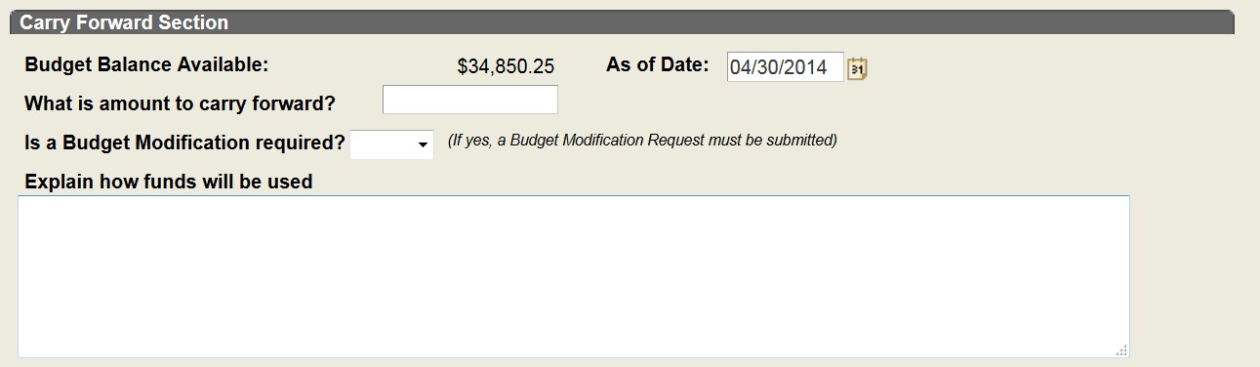

Some sponsors restrict the amount of funds that may be automatically carried forward to the next budget period. If all funds are not spent by the end of a budget period, the PI may wish to use the unobligated balance or remaining funds in the next budget period. In such cases, the PI must request the carry-forward in writing, countersigned by SPARCS, and explain why there are funds remaining at the end of the budget period and how the funds will be used in the next budget period.

Change in PI or Key Personnel
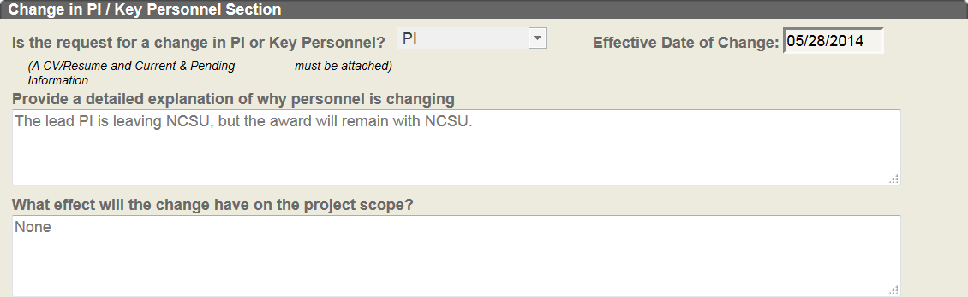
Sponsors award funding with the expectation that the named investigator will be responsible for directing or overseeing the project. If the investigator’s involvement is reduced or is not available for any reason, immediate notification to the sponsor is needed.
The University may request a change in PI on a grant for any of the following reasons:
- The PI transfers to industry or to another institution and is ineligible to continue the project.
- The university the PI is transferring to is ineligible to receive funds.
- Untimely death, serious illness, or injury renders the PI unable to continue work on the project.
- Change in the percentage of effort available by the PI to work on the project.
- Change of circumstances that require the PI's continued absence from the university or project for more than 3 months (e.g., sabbatical or military leave).
- Other circumstances that, in the opinion of the University, necessitate a change in PI.
A detailed justification must be provided explaining how the change will affect the overall project, effective date of the change, purpose of the change and qualification of the New PI (CV/resume).
These requests must also be approved by the Department Head prior to routing to the SPARCS Office for review and processing.

Change in Scope
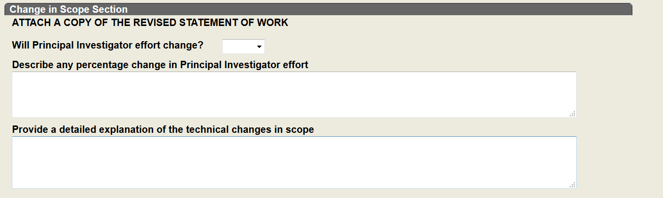
Sponsors award funding with the concept that the proposed scope of work will be fulfilled with the approved funds.
In general, the Principal Investigator (PI) may make changes in the methodology, approach, or other aspects of the project objectives. However, the grantee must obtain prior approval from sponsoring agency for changes in scope, direction, type of training, or other areas that constitute a significant change from the aims, objectives or purposes of the approved project. The grantee must make the initial determination of the significance of a change and should consult with the College Research Office (CRO) as necessary.
The PI or sponsor may request a formal change in scope, an explanation for the revised statement of work and budget, purpose of the change, any change in PI’s effort and if supplemental funding will be needed.
Note: After a grant or contract has been awarded, the PI or sponsor may determine that the approved scope is not consistent with actual needs or direction the project.

Equipment Acquisition
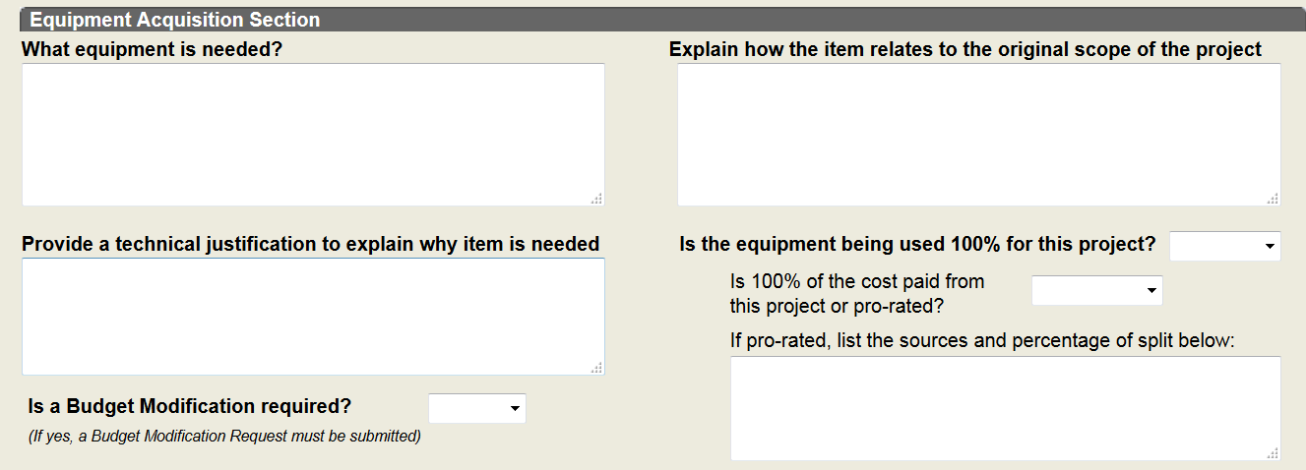

Equipment means tangible personal property (including information technology systems) having a useful life of more than one year and a per-unit acquisition cost which equals $5,000 or more.
The purchase of capital equipment (equipment with a unit cost of $5000 or more) often requires prior approval by the sponsor if:
- the purchase of capital equipment was not included in the award budget, or
- the PI or PD wishes to purchase a piece of capital equipment different from that included in the award budget
Provide a generalized specification (cost, description) and justify the need for the equipment in relationship to the statement of work (why do you need the equipment).
NOTE: Equipment should not be purchased within the last 3 months of the project.
These requests must also be approved by the Department Head prior to routing to the Office of Contracts & Grants for review and processing.

Fabricated Equipment
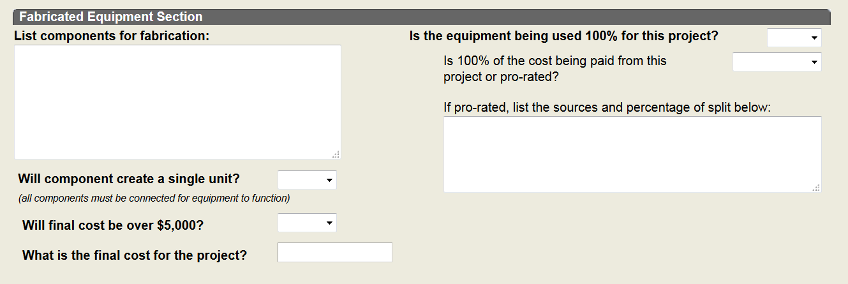
Fabricated equipment is defined as an item of equipment that is built or assembled in its original form from individual parts by a PI and/or other sponsored project personnel, an internal shop, or an external shop.
If a fabricated equipment item will have an aggregate cost of less than $5,000, the individual costs for all acquisitions are subject to the relevant F&A rate. If you initially anticipate that the total fabrication will cost more than $5,000 and as such exempt the individual components from F&A but the final product ends up aggregating to less than $5,000 then all component costs will then be subject to F&A.
An instance where components are simply connected together in a system, such as when individual computers and servers are joined to create a network, does not constitute a fabrication.
Remember: If ownership of the final product is to transfer to the sponsor, the F&A rate applies to the individual fabrication components.
For fabricated equipment, be prepared to give the following:
- Sponsor and award type (grant/contract)
- Time frame for completing fabrication
- Estimate dollar amount
- Whether the item is a deliverable or not
- Components and individual costs

Fabrications Notes:
  - Must be approved by C&G
  - If approved then items under $5,000 can post to 55xxx, as long as they are not listed below as a “Never Capitalizable” item, and they are used in the final fabrication. Spare parts and repair parts cannot be included and would have to be moved back to the supply line.
  - Items simply wired together do not count as a Fabrication and will be reviewed individually.
  - Departments must notify the Capital Asset Group upon completion of a Fabrication, with a full listing of all charges included in the final fabrication for a final review, approval, and capitalization (if warranted) of the fabrication into Asset Management.
Never Capitalizable:
- Supplies, consumables, replacement/repair parts
- Modular workstations and cubicle offices.
- Warranties
- Maintenance Contracts
- Subscription Services
- Professional Services (Not Installation, Training, or Shipping/Freight)
When a Fabricated Equipment request is approved and the Approval Email generated, it is the Fiscal Manager’s responsibility to update the Inventory Indicator attribute. The Fiscal Manager will change the attribute based on whether an inventory is required.
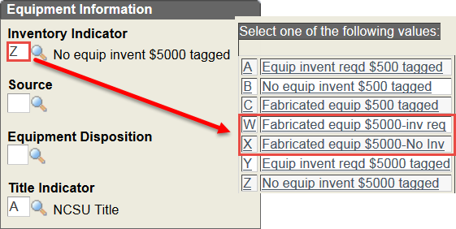

Primary Criteria for Capitalization: Per Asset Management Guidelines

Must qualify under each of the following criteria….
- Cost Threshold
  - $5,000.00 for a single piece of equipment (1 Computer, 1 Car, 1 RL Recorder)
    - Include additional cost for Shipping/Freight, Installation, & Training
  - $100,000 for a single Software License
- Life Expectancy
1) 2 or more years of life (ie subscriptions, rentals, leases for less than 1 year – not capital)
- Physical Makeup of item
- Singular Piece of Functional Equipment/Software
  - Computers, Monitors, Keyboards, Printers are all separate items
- C&G Approved Fabrication
  - When parts are purchased in order to build a single piece of equipment. Ex. Capital Fabrication - Buy tires, an engine, a frame, some axles, etc to build a car (the pieces used in the final car would be allowed to be capitalized as a Fabrication)
  - Ex. Non-Capital Fabrication – Buy three computers and a router, which are then wired together (This is not a Fabrication)

No Cost Extension (NCE)
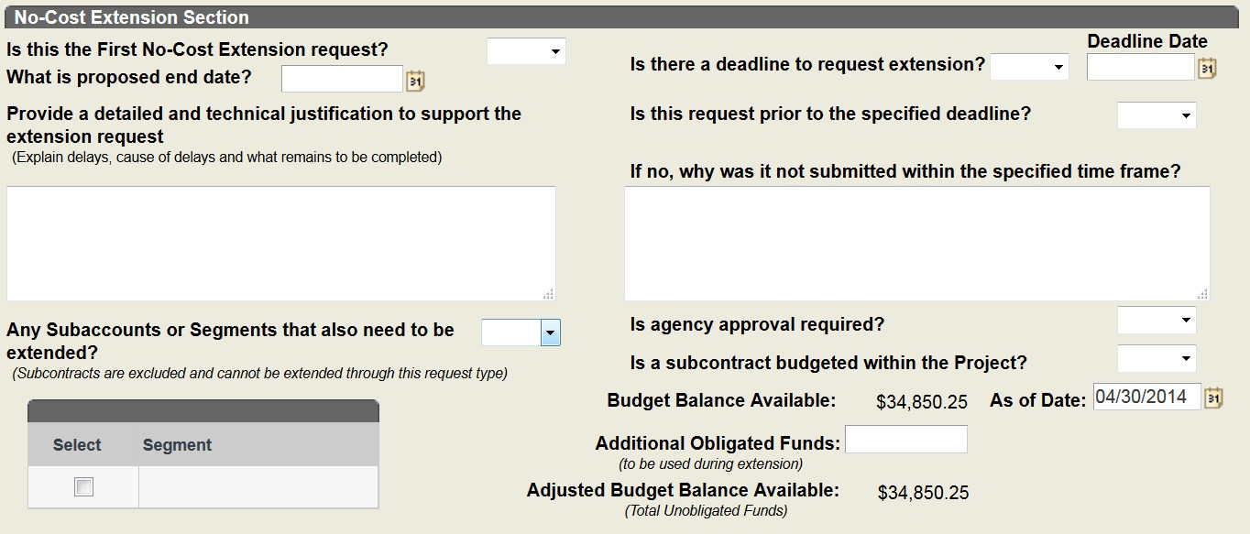
While sponsors expect Principal Investigators (PI) to complete projects by the stipulated end date, occasionally extra time is needed. A no-cost extension gives the PI extra time to complete the scope and objectives of the project without additional funds being provided by the sponsor. Although request may not be made for the sole purpose of spending remaining funds, you may expend remaining funds during the no-cost extension period. In the event your request is not approved, costs incurred after the end date would not be allowable.
The justification for the request must include information regarding the current project end date to the expected new end date, the amount of additional time requested, and the reason for the request. You should explain the scientific need for the extension, reason for the delay and what remains to be completed.
When requesting a NCE, sponsor’s terms and conditions must be adhered. This may require additional forms, budget or justification.
When a requested is submitted for a project with a Subcontract budgeted within the Prime, the NCE request will apply to that Prime/Parent only. It will not extend the Subcontract. To extend the Subcontract, a SubAward (Modify) request must be submitted.
Note:
The SPARCS Office will be responsible to entering the NCE information into the agency databases which include but are not limited to Fastlane, NASA, eRA Commons, Grants Online, Grant Solutions.

PreAward Cost
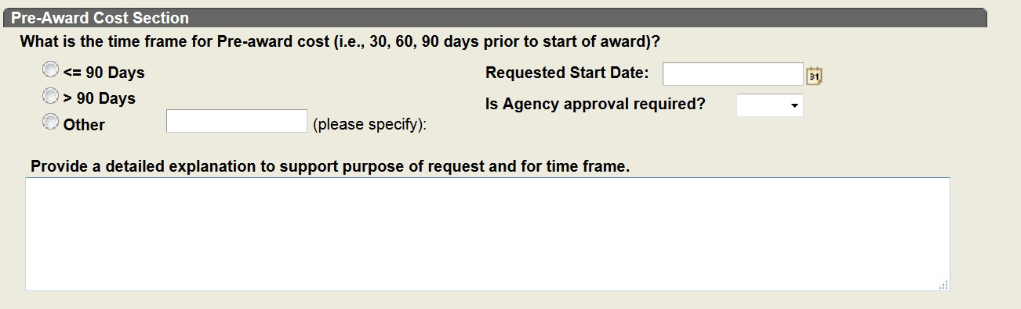
Most sponsors allow grantee institutions to incur pre-award costs up to 90 days prior to the start date of a grant award.
If pre award costs are not approved in the signed agreement, then agency approval is needed. The pre award costs must be for the effective and economical conduct of the project, and allowable on the project.
The request should contain the effective date of the request, a justification and explanation of type of change (payroll will require additional changes).

Subaward(s)
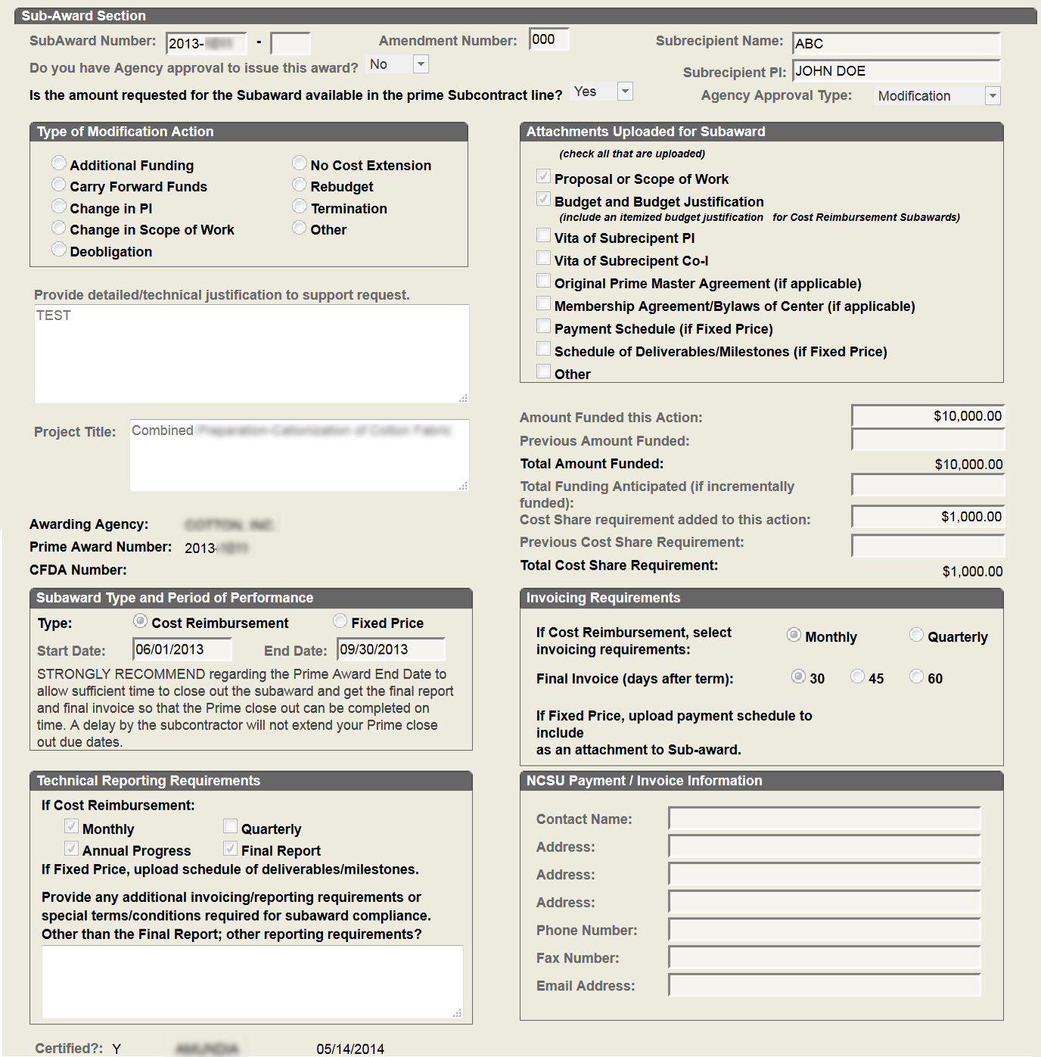
Subrecipients are entities that will contribute to the programmatic portion of the project. Their performance will be measured against whether the objectives of the project are being met. Subrecipients ARE subject to project compliance.

As the recipient of an award for a sponsored research project, the University may award financial assistance to a Subrecipient to facilitate performance of and payment for specific work to be conducted by the Subrecipient in connection with the sponsored project. A Subaward may be issued by the University as the recipient of a prime award or as the Subrecipient of another institution's prime award.
Therefore, Subrecipients must adhere to the University’s awarded terms and conditions. Subrecipients should provide a detailed budget similar to NCSU’s budgeted categories (i.e. salary, fringe benefits, travel, equipment, materials & supplies, consultants, indirect costs, etc.). Please note – if there is a sponsor restriction on F&A, direct costs, etc. then our Subrecipients must also adhere to said restriction in their budgets.
Subcontract agreement must be approved by the sponsor and include the following:
- A current CV/Resume
- Statement of work
- Budget justification (new, supplement or de obligation)
- Budget/project dates must fall within the range of the direct sponsor.
- Final reporting and billing due 30 to 60 days prior to term date of direct sponsor.
Termination of Subawards

Upon termination of any Subaward issued from NCSU to another institution, all financial, technical, property, patent, and other required reports should be received from the Subrecipient along with a statement that it releases NCSU from all further claims under the Subaward. The NCSU PI should indicate that the Subaward was carried out in accordance with the work statement.

Note:
Campus Users are REQUIRED to complete AND upload the Subaward Action Request form when submitting a request to issue or modify/terminate a Subcontract.

Travel
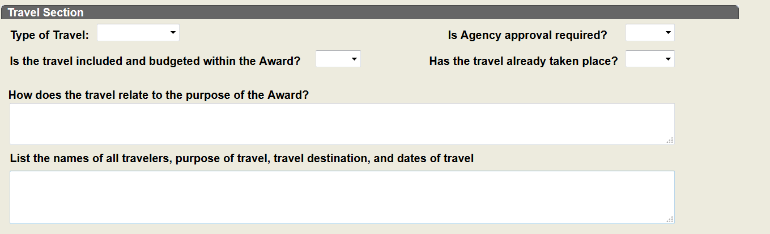
Domestic and foreign travel is a common activity that Principal Investigators (PI's) and research staff may engage in during the course of an award.

Sponsored travel must be justified, well documented, in compliance with the sponsor requirements and must be incurred within the period of the award.

The traveler must have effort on the project. The travel charges related to the traveler must be paid or cost shared from the sponsored award.

Travel costs must be:
- Allowable: Travel must be allowed under the terms of the award.
- Allocable: The travel is necessary to fulfill the programmatic objectives of the award charged for the travel expense.
- Reasonable: The travel costs are reasonable and not excessive; examples of excessive include stays at luxury hotels, expensive restaurants, the use of limousines, etc.
The trip must specifically benefit the project.
  - The trip must have prior written approval on file.
  - Funds must be available for the travel.
  - If not in approved budget, agency approval is required
  - Is foreign travel being charged to a federal award? If yes, foreign travel must be in compliance with the Fly America Act.

Other
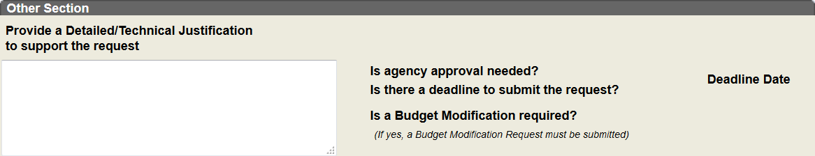
The “Other” template should only be used when the request you need to submit does not fit within one of the other ten (10) request type.

Listed below are some examples of the type of requests that should be submitted under “Other”:
- Change in the percentage of effort available by the PI to work on the project. This is change in percentage only and does NOT include a Change in PI.
- Change of circumstances that require the PI's continued absence from the university or project for more than 3 months (e.g., sabbatical or military leave). This does NOT include a Change in PI
- De-obligation (non-Subawards)
  - A sponsor or PI may decide at any time to decrease the level of funding for an active project for various reasons (early termination, stop work, cut in funding, etc.).
  - A detailed justification explaining the purpose, amount, change in scope, PI effort and period change will need to be documented and approved
- Outgoing PI Transfer
  - When a faculty member transfers to another institution and has received permission from his/her department and college to transfer the project.
    - Upon receipt of the necessary departmental and college approvals, contact Debbie Shoe, COI Protocol Manager to begin the initial phase of the transfer
    - When instructed by Debbie Shoe, COI Protocol Manager to submit a PMR
      - Include a justification, effective date, and where the PI is going.
59 | P a g e

    - Prior to routing request to C&G, it is the responsibility of the GBO to Adhoc in Prior Approval Coordinator - Kathi McFadden (KSMCFADD) and Assistant Director, Operations - Stefanie Saunders (SDSAUND2) as a Reviewer after C&G and then COI
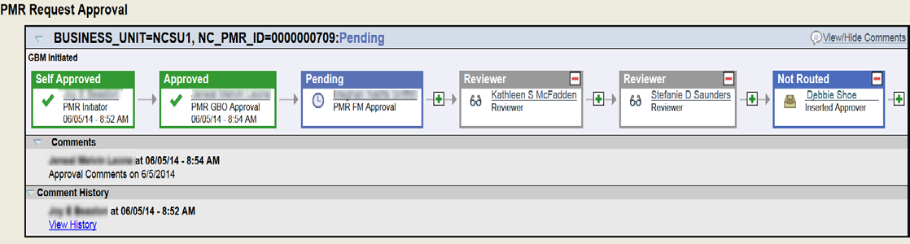
Protocol Manager - Debbie Shoe (DHHUNT2) as the final
Approver for the request.
- Early Termination
In certain instances, a project may terminate prior to the original expiration date, due to:
  - Accelerated rate of spending exhausts sponsored funds
  - PI leaves the institution and the project will not be transferred or assigned a new PI
  - Sponsor’s level of funding is reduced
  - Sponsor requests termination
  - Sponsor sends a Stop Work Order or Notice of Suspension (See instructions in the Stop Work Order section)
Award agreements typically include a clause for how an early termination situation will be handled. Generally, such notices would be sent by the sponsor to SPARCS, who should contact the Grant Business Officer (GBO) immediately.
If the notice is sent directly to the PI, a copy should be forwarded to SPARCS immediately. SPARCS will work with the GBO to evaluate the notice and plan a formal response to the sponsor.
Important: In the event of early termination, all required reports, such as financial, technical, and patents, must still be provided to the sponsor.

PMR Processing:
- A PMR should be submitted with the dates for the termination, the unobligated balance and a justification for the early termination.

- Stop Work Order

A Stop Work Order is a formal notice to cease or hold work on a contract. If not followed by an order to resume work, it amounts to termination of the contract.
- Stop-work orders may be used, when appropriate, in any negotiated fixed-price or cost-reimbursement supply, research and development, or service contract if work stoppage may be required for reasons such as advancement in the state-of-the-art, production or engineering breakthroughs, or realignment of programs.
- Generally, a stop-work order will be issued only if it is advisable to suspend work pending a decision by the Government and a supplemental agreement providing for the suspension is not feasible. Stop-work orders shall not be used in place of a termination notice after a decision to terminate has been made.
- Stop-work orders should include—
  - A description of the work to be suspended;
  - Instructions concerning the contractor’s issuance of further orders for materials or services;
  - Guidance to the contractor on action to be taken on any subawards; and
  - Other suggestions to the contractor for minimizing costs.
- Promptly after issuing the stop-work order, the contracting officer should discuss the stop-work order with the contractor and modify the order, if necessary, in light of the discussion.

- As soon as feasible after a stop-work order is issued, but before its expiration, the contracting officer shall take appropriate action to—
  - Terminate the contract;
  - Cancel the stop-work order (any cancellation of a stop-work order shall be subject to the same approvals as were required for its issuance); or
  - Extend the period of the stop-work order if it is necessary and if the contractor agrees (any extension of the stop-work order shall be by a supplemental agreement).

PMR Processing
  - For a PI initiated Stop Work Order, a justification indicating the purpose for the request, and official date to stop work

  - For agency imposed Stop Work Order, a copy of the letter from the agency must be sent to sps@ncsu.edu to begin processing the Stop Work Order.

  - C&G will process the Stop Work Order upon receipt of the Award Notice from SPARCS.

- Research Experiences for Undergraduates (REU) is awarded from a sponsoring agency for a specific student.
  - A change in personnel, and a realignment of budget categories should be processed as PMR Type Other.

- Participant Support Cost (PSC) requires written prior approval from the agency to reallocate funds provided for PSC.
  - A request should be processed as PMR Type Other.

Internal Award vs Segment:

INTERNAL AWARDS:
- An Internal Award is where the University awards funds under the delegated authority issued by a Sponsoring Agency.

- An Internal Award issued under delegated authority will have a RADAR # that is different from the Prime Award.
A Prime Award is identified as the initial award issued to the university. Once the Prime award is received at the University, the Internal Agency Representative will issue awards internally and/or externally based on the funds initially received from the sponsoring agency.

Note:
For an external award (i.e., outside of NCSU), the requests should be submitted as a Subaward New or Modification.

SEGMENTS:
- An Internal Award “Segment” for a NCSU Principal Investigator when created when a Project ID is needed for either of the following reasons:

  - To distribute or issue award funds
  - To separate restricted funds
  - To account for specific award changes
For Example: Participant Support Cost (PSC), Research Experience for Undergraduates (REUs), Projects requiring the segregation of Next Year Funding, etc.

Note: The RADAR # for the Internal Award “Segment” will be the same as the Prime Award Radar #.

Internal Award Processing Notes:
Internal Award – Internal Segment:
Project Modification Requests relating to an Internal Award –“Segment “MUST include a detailed justification explaining the type of modification required.
To process modification requests, approval is required from the Lead PI named on the
Prime Award.
If the necessary approvals are obtained prior to submitting the request, the written approval must be uploaded to the request.
If the necessary approvals have not been obtained, the Initiator must ensure the GBO is inserted as an Adhoc Approver.
Note: The ability to specifically insert the GBO of another College prior to the initiator’s GBO depends on the initiator’s PMR Role and whether the initiator’s requests will route directly to their GBO or another approver prior to the GBO.
For example, if the initiator is the GBM, the request when submitted will route directly to the GBO. Therefore, the initiator will not be able to insert the other college GBO prior to their GBO. Thus meaning, the other college GBO approval must be obtained outside of PMR.
If the initiator’s request needs to route for an additional approval, the initiator will be able to insert the name of the GBO from another college prior to their GBO. This is contingent upon the workflow setup and the position of the desired additional approval.

For request related to an Internal Award “Segment” routed to SPARCS for final approval:
PMR Approvers with the SPARCS Approval Role will process the request in the following manner:
- SPARCS (SP) will review request for adherence to applicable guidelines
- The Processor, Negotiator and Sponsor approvals are not required
- SP will not generate an Award Notice
- SP will insert the C&G Fiscal Manager as an Adhoc Approver prior to approving request.
  - The Fiscal Manager will process the request in the following manner:
    - Review request for completeness and accuracy
    - Approve or Deny PMR
    - Upon approval, Print a copy of the request
      - PMR status should be = “completed”
    - Update Attribute Information

Internal Award – Internal Agency:

Project Modification Requests relating to awards issued by an “Internal Agency” MUST include a detailed justification explaining the type of modification required.
- The C&G Fiscal Manager or PMR Approvers with the SPARCS Approval Role (i.e., “Triage Stage”) will review the request for completeness and accuracy.
- Upon review of the request, the C&G Fiscal Manager or PMR Approvers with the SPARCS Approval Role (i.e., “Triage Stage”) will insert the Internal Agency Representative as an Adhoc Approver prior to approving the request.

Note: The Internal Agency Representatives are typically the GBO for the designated college.

- Campus Users with “Delegated Authority” to act on the behalf of a Sponsoring Agency must next process and submit the request in RADAR. Processing involves Issuance of the Internal Award Notice.

  - RADAR will generate an email to the GBO, SPS@ncsu.edu and additional recipients entered.

- The SPARCS Assistant Director, Operations will assign the request in RADAR for processing

- The SPARCS Centers Coordinator will upload and print necessary paperwork
- The SPARCS Compliance & QA Accountant will perform a final Quality Control (QC) Review of the Award Paperwork

- The SPARCS Compliance & QA Accountant will forward the Award Paperwork to C&G for processing
- Upon receipt of the Award Paperwork, the C&G Fiscal Manager will:
  - Print the PMR
  - Update the attribute information based on the new award or modification documentation

The NCSU Internal Agency Representatives include but are not limited to:

Internal Award - Agency
Center for Dielectrics & Piezoelectrics (CDP) NCSU Sea Grant Program
Laboratory for Analytic Sciences (LAS)
NCSU Future Renewable Electric Energy Delivery & Management Systems Center (FREEDM)
NCSU NC Space Grant Consortium
NCSU Research & Innovation Seed Funding Program
NCSU Advanced Self Powered Systems of Sensors and Technologies (ASSIST)
NCSU Water Resources Research Institute (WRRI)
Biomass to Biochemical & Biomaterials Consortium (BTB2c) NCSU Industrial Extension Service (IES)
NCSU Professional Science Master
Center for Integration of Composites into Infrastructure (CICI) – NCSU Research Site
Forest Biotechnology Industrial Research Consortium (FORBIRC)
NCSU Silicon Solar Consortium (SiSoC) Research Center
Center for Bioenergy Research and Development (CBERD) – NCSU Research Site
Southern Forest Resource Assessment Consortium (SOFAC) NCSU Ergonomics Center of North Carolina (ECNC)
NCSU Nonwovens Cooperative Research Center
NCSU Center for Engineering Applications of Radioisotopes (CEAR)
NCSU Center for Innovation Management Studies NCSU Precision Engineering Center
Contact Name
Pat Hayes / Rosette Tavolacci Mary Beth Barrow
Ginny Moser / Gail Platt
Pat Hayes / Rosette Tavolacci

Pat Hayes / Rosette Tavolacci Pat Hayes / Rosette Tavolacci Pat Hayes / Rosette Tavolacci

Mary Beth Barrow Larisa Slark
Pat Hayes / Rosette Tavolacci Stefanie Saunders
Pat Hayes / Rosette Tavolacci Ellen Sanders, Interim Director
Pat Hayes / Rosette Tavolacci Pat Hayes / Rosette Tavolacci

Ellen Sanders, Interim Director
Larisa Slark
Larisa Slark / Kina Morgan Larisa Slark
Brian Thomas Larisa Slark

Where to get help:

Help Processing a Request: (I.e., Help not related to system access)
- How do I enter a request and what is required?
  - Contact your College Grant Business Officer for assistance
- If you have submitted a request and need to check the status of the approval
  - Review the approval and processing comments within the PMR
  - For additional assistance, contact your college Grant Business Officer
  - Contact appropriate Central Office for assistance (i.e., C&G or SPARCS)
- If you have access to PMR but need other assistance with how to process a request, listed below are your contacts in order of priority.

- Departmental Representative
- College Grant Business Officer

- For C&G Requests:
  - C&G Fiscal Manager assigned to Project
  - C&G PMR Help Desk Email – cnghelpdesk@ncsu.edu
  - C&G PMR Help Desk Phone – 919-513-7954
- For SPARCS Requests:
  - Send email to pmr-modifications@ncsu.edu

Where do you get help with system or access issues:

USERS ARE NOT REQUIRED TO SUBMIT A SAR REQUEST TO GAIN ACCESS
- If you are Department Bookkeeper, Contract Manager or Grant Manager (i.e., GADM Role) and do not have access to PMR – contact your Grant Business Officer (formerly, CBO or CRO)

- If you are a College Reviewer or Approver or have designated college approvals (i.e., GBM Role) and do not have access to PMR – contact your Grant Business Officer (formerly, CBO or CRO)

- If you are a Department Head or Designee and do not have access to PMR –

contact your Grant Business Officer (formerly, CBO or CRO)

- If you are the Grant Business Officer (GBO) or Designee and do not have access to PMR – Contact Thelia Burrell via phone at 919-515-8006 or via email at thelia_burrell@ncsu.edu.

- General System access issues - Contact Thelia Burrell via phone at 919-515- 8006 or via email at thelia_burrell@ncsu.edu.

Viewing PMRs through the PI Portal / Research Admin Portal:

The PMR tab within the PI Portal will provide the viewer a complete list of all PMRs submitted per project.
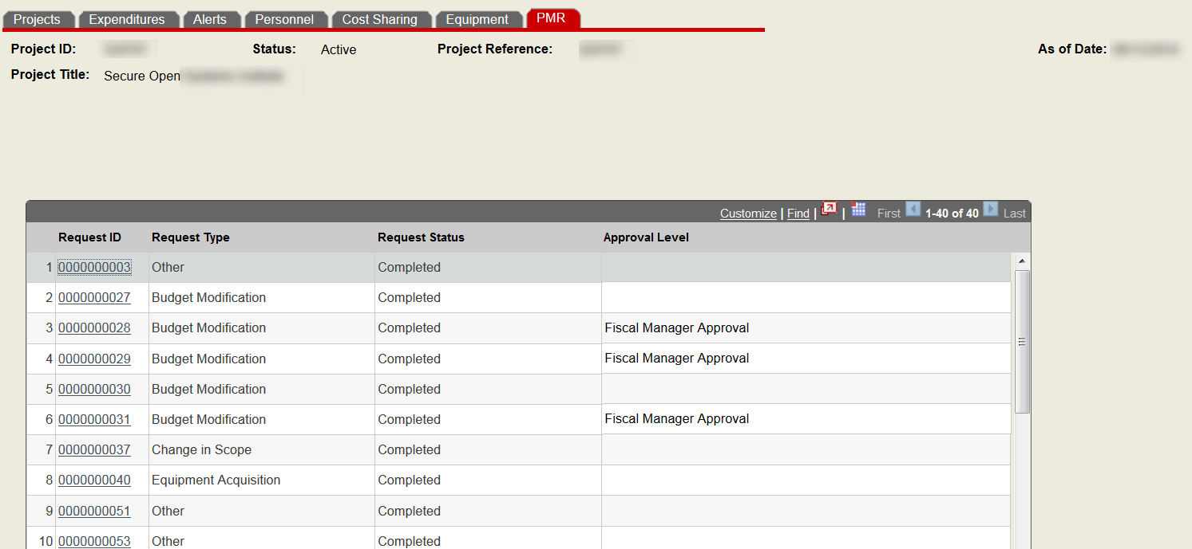

The PMR list includes the Request ID, Request Type, Request Status and Approval Level.
Press the PMR Request ID hyperlink to open the PMR request

The Approval Level column will indicate the current approval needed to continue processing the PMR.

Note:
Requests with a “Completed” Request Status will have NO information in the Approval Level Column. The field will be blank.

NC State University Glossary of Research Terms

A
- A-110 - OMB Circular/Uniform Administrative Requirements for Grants and other Agreements This Circular sets forth standards for obtaining consistency and uniformity among Federal agencies in the administration of grants to and agreements with institutions of higher education, hospitals, and other
non-profit organizations. The standards set forth in this circular are applicable to all Federal agencies.
- A-21 - OMB Circular/Cost Principles for Educational Institutions This Circular establishes principles for determining costs applicable to grants, contracts, and other agreements with educational institutions . The principles deal with the subject of cost determination. The circular applies to all Federal agencies that sponsor research and development, training, and other work at educational institutions shall apply the provisions of this circular in determining the costs incurred for such work. A-21 determines the terms of direct and indirect costs, allowable and unallowable expenditures, and now sets the terms of Cost Accounting Standards.

- A-133 - Audits of States, Local Governments, and Non-Profit Organizations - used in auditing federal assistance and federal grant programs, as well as their respective recipients.

- Account Number - Refers to the financial account number used for spending money associated with the project.
- AERL - Applied Energy Research Laboratory
- AFOSR - US Air Force Office of Sponsored Research

- Agencies (also known as sponsors) - Institutions (usually a state or federal body) that sponsor a research endeavor, providing funds and other support. There are very many of these, and most of them are referred to using acronyms. The National Council of University Research Administrators (NCURA) offers and explanation of these acronyms, with links to the relevant agency sites: http://www.ncura.edu/agencies/default.html.

- Allowable Costs - Determined by the Office of Management and Budget (OMB), the sponsor's requirements and/or university policy. OMB circular
A-21 defines allowable costs as those that are: 1. Reasonable, 2. Allocable to the project, 3. Given consistent treatment by the use of generally accepted accounting principles, 4. Conform to any limitations or exclusions set forth by the sponsored agreement or OMB Circular A-21.

- Allocable Costs-Those allowable costs that actually benefit the grant or contract to which they are being charged.

- AOR - Authorized Official Representative – an individual who is authorized to sign and submit proposals on behalf of the University
- ARO - Army Research Office

- Award - Funds provided from an external sponsor for support of a project at the NC State University. This term is used for both original award and supplements.

B
- BAA - Broad Agency Announcement - a technique for United States government agencies to contract for basic and applied research and certain development
- BOT - NCSU Board of Trustees – Per the UNC Code, The Board of Trustees shall promote the sound development of its institution within the functions prescribed for it, helping it to serve the people of the state in a way that will complement the activities of the other institutions and aiding it to perform at a high level of excellence in every area of endeavor. Each board of trustees shall serve as an advisor to the Board of Governors on matters pertaining to its institution and shall also serve as advisor to the Chancellor concerning the management and development of the institution.

- Budget - An estimate of expenditures proposed to be incurred in the performance of a proposed statement of work.

- Budget Category - A portion of the budget designated for certain kinds of expenditures, e.g., salaries, operations, travel, equipment.

C
- CAS - Cost Accounting Standards

- CDC - Center for Disease Control
- CES - Cooperative Extension Service

- CFDA - The Catalog of Federal Assistance – government-wide list of Federal programs, projects, services, and activities which provides assistance and benefits to the American public

- CFR - Code of Federal Regulations

- CIS - Centers and Institutes

- CO - Contracting Officer

- Colleges – NC State University

  - CALS - College of Agriculture and Life Sciences
  - COD – College of Design
  - CED – College of Education
  - COE - College of Engineering
  - CHASS - College of Humanities & Social Sciences
  - COM – College of Management
  - CNR – College of Natural Resources
  - COS – College of Sciences
  - COT – College of Textiles

  - CVM – College of Veterinary Medicine
- Co – I / Co – Investigator - An individual involved with the principal investigator in the scientific development or execution of a sponsored project.

- Conflict of Interest (COI) and COI Certifications-(Disclosure of Financial Interest) - Faculty, EPAs and SPAs/Grads paid from a ledger 5 account must annually disclose their financial interests outside of the university via the university’s electronic COI disclosure system. Institutional representatives certify that the institution has implemented and is enforcing a written policy on conflicts of interest consistent with federal regulations, all financial disclosures required by the conflict of interest policy were made; and that conflicts of interests, if any, were, or prior to the institution's expenditure of any funds under the award, will be satisfactorily managed, reduced or eliminated in accordance with the institution's conflict of interest policy and/or disclosed to the agency (as required by the agency). http://www.ncsu.edu/sparcs/coi/index.php
- Consortium - A consortium is two or more institutions working on the same research project, either funded directly by the supporting agency or one prime institution subcontracting out the funds to the other members of the consortium.

- Contract - A contract is an agreement to acquire services that primarily benefit the sponsor. For an award to be considered a contract, it normally must contain all of the following elements:
  - Detailed financial and legal requirements must be included with a specific statement of work to be performed.
  - A specific set of deliverables and/or reports to the sponsor is required
  - Separate accounting procedures are required
  - Legally binding contract clauses must be included
  - Benefits of the project accrue first to the sponsor, then to the university, then to the nation.

- Contracts and Grants office (C&G) - Post Award office at NC State University, who oversees the financial management of sponsored project accounts.

- Contributed Effort - Effort expended on a sponsored project that the sponsor does not compensate for; a form of cost sharing
- Cooperative Agreement - A funding mechanism which can be used by federal agencies when a program requires more agency involvement and restrictions than a grant but requires less agency supervision than a contract.

- Co-Principal Investigator (Co-PI) - One investigator sharing equal responsibility for the direction of a research program. (PHS/NIH does not recognize the concept of co-principal investigator.)

- Copyright - A copyright is a form of protection provided for under the U.S. Constitution to the authors of an "original work of authorship" that is in a tangible form. An original work of authorship protected by U.S. Copyright law could include literary works, musical works, pantomimes, choreographic works, pictorial, graphic and sculptural work, motion pictures and other audiovisual works, sound recordings, and architectural works. Copyright protection exists from the time the authored work is created in a fixed tangible form and the work of authorship immediately becomes the property of the author who created the work.

- Cost Reimbursement (CR) - A type of agreement whereby payments are based on actual allowable costs incurred in performance of the work.
- COR - Contracting Officer’s Representative
- COS - Community of Science/Scholars

- Cost Share - University and nonfederal sponsor resources provided in support of sponsored programs; includes contributed effort and matching funds.

- CRA - Certified Research Administrator

- CRO - College Research Office

- CV - Curriculum Vitae – primarily use for faculty, the CV provides a comprehensive overview of a person's experience, publications and other qualifications.

D
- Dean - Person with highest authority over a specific academic unit (college). DEHNR/DENR - Department of Health, Environment and Natural Resources DFAR - Department of Defense Federal Acquisition Regulation Supplement

- DHHS - US Department of Health & Human Services and/or NC Department of Health & Human Services
- Direct Costs - Direct costs are all costs that can be directly attributed to the conduct of the project and are specified in the proposal budget. These costs can be readily identified and are itemized by name and amount.

- Direct Sponsor - Refers to the organization that funds the project

- DOD - Department of Defense

- DOE - Department of Energy
- DOEd - US Department of Education

- DOT US Department of Transportation

- DTRA - Defense Threat Reduction Agency

E
- Effort - The amount of time, usually expressed as a percentage of the total, that a faculty member or other employee spends on a project. Effort is certified and documented through the TEARS Effort Certification Reporting system.
- Effort Reporting - Effort reporting and certification form required for compliance with federal regulations.
- EPA Employee – Employee who is exempt from the State Personnel Act of NC. These employees do not earn overtime and are exempt from federal Fair Labor Standards.

- EPA - Environmental Protection Agency

- Equipment - Means tangible nonexpendable personal property including exempt property charged directly to the award having a useful life of more than one year and an acquisition cost of $5000 or more per unit.

- ERA - Electronic Research Administration - Many sponsors now rely upon electronic communication (email) with their grantees and upon secure sites to receive grant applications, to communicate funding decisions, to accept reports, and to close out research projects. Electronic Research Administration is the term used to describe the method most sponsors are employing to handle the grant application, award, and management process.

- Expanded Authorities - Policy implemented by some federal granting agencies which delegates certain prior approval authorities to grantee institutions. This delegation allows for internal university approval of administrative and spending actions, thus avoiding delays in project progress.

F
- Facilities and Administrative (F&A) Cost Rates - Facilities and Administrative costs (F&A; also referred to as indirect costs or overhead) are those costs associated with the conduct of sponsored activities that are incurred for common or joint objectives and therefore are not readily identifiable with a specific project. Examples of costs normally considered to be F&A costs include administrative/clerical; facilities management and utilities;
general-purpose equipment; office supplies; postage; memberships and dues; subscriptions/books/periodicals and local telephone charges.
Negotiated, approved rates are to be used for all agreements with the federal government and for most non-federal projects, as allowable.
- FAQ - Frequently Asked Questions

- FAR - Federal Acquisition Regulations - is the principal set of rules in the Federal Acquisition Regulation System. This system consists of sets of regulations issued by agencies of the federal government of the United States to govern what is called the "acquisition process"; this is the process through which the government purchases ("acquires") goods and services. That process consists of three phases: (1) need recognition and acquisition planning, (2) contract formation, and (3) contract administration. The FAR System regulates the activities of government personnel in carrying out that process. The FAR is codified in Title 48 of the United States Code of Federal Regulations

- FAS - Financial Accounting System

- F&B - NC State University Division of Finance and Resource Management. C&G is part of this division.
- FDP - Federal Demonstration Partnership - The Federal Demonstration Partnership (FDP) is an association of federal agencies, academic research institutions with administrative, faculty and technical representation, and research policy organizations that work to streamline the administration of federally sponsored research.

- FFATA - Federal Funding Accountability and Transparency Act; requires reporting of all Subrecipient awards above $25,000.
- FRPD - Faculty Research & Professional Development - This individual investigator fund is intended to assist faculty members in initiating research and professional development activities. A primary objective from an award should be to use the funding as "seed" money leading to support from outside granting agencies. This funding is made available via a partnership of resources from the division of Research, Innovation and Economic Development (ORIED) and college Dean’s offices.

- FSR - Financial Status Report – report completed by C&G.
- Firm Fixed-Price (FFP) -A type of agreement whereby payment is not based on actual costs expended but upon a mutually agreed upon price.

- Formal Proposal - Any proposal submitted by a university employee to an outside entity that may directly lead to an award. All formal proposals require an institutional endorsement by an official authorized to commit university resources. NOTE: ONLY ELECTED MEMBERS OF THE FACULTY MAY SUBMIT GRANT PROPOSALS. ELECTED MEMBERS OF THE FACULTY
INCLUDE: Professors, Associate and Assistant Professors, Instructors and Lecturers.

G
- GA - General Administration of UNC system
- Gift - A unilateral transfer of money, property, or other assets to the recipient for the recipient's ownership and use by a donor who makes no claims on the recipient in connection with the gift. Gifts normally have the following characteristics:
  - The statement of work allows the project director significant freedom to change emphases within the general area of work as the project progresses.
  - No deliverables are involved
  - Separate accounting procedures are not required
  - Benefits of the project are to accrue to the nation and the world
  - Sponsor has no audit rights
  - No regulatory issues are involved, such as human subjects or animal care.
- GL - General Ledger
- Grant - An agreement to transfer money, property, services, or anything of value to accomplish a purpose, such as support or assistance in an area of interest to the grantor. For an award to be considered a grant, it normally will contain the following elements: 1. The statement of work allows the project director significant freedom to change emphasis within the general area of work as the project progresses. 2. Deliverables are minimal, usually consisting of reports only. 3. Separate accounting procedures are required.

- Grantee - A grantee is the recipient of a grant. When the university accepts a grant award, on be-half of an individual, it becomes the grantee.

H
- Human Subjects - A living individual about whom an investigator conducting research obtains: 1. Data through intervention or interaction with the individual. 2. Identifiable private information.

- HUD - Housing and Urban Development

I
- In-Kind Contribution - A non-cash commitment (such as contributed effort, facilities use, or supplies) to share the costs of a sponsored project.
- Indirect Costs - See Facilities and Administrative (F&A) Costs.

- Informal Proposal - A short (generally 2-5 pages) description of the proposed project that does not involve a commitment of university resources or a signature on behalf of the university. An informal proposal may include a total cost estimate but does not include a budget and is not expected to result directly in an award. The purpose of an informal proposal is usually to inform and interest the potential sponsor enough to request a more detailed formal proposal. Also sometimes called a letter proposal, mini-proposal, preliminary proposal, pre-application, or concept paper.

- Informed Consent - The voluntary agreement obtained from a subject (or the subject's legally authorized representative) to participate in research or related activity, before participating in that activity. The consent must permit the individual (or legally authorized representative) to exercise free power of choice without undue inducement or any element or deceit, fraud, force, duress, or other form of coercion or constraint.

- Institutional Authorized Officials - Individuals authorized by the Board of Regents to sign grants, contracts, and agreements on behalf of NC State University.

- Institutional Review Board (IRB) - A board or committee organized at the university to provide review at the institutional level for ethical concerns in research, such as laboratory animal care and the use of human subjects in research.

- Intellectual Property (IP) - Intellectual property is a broad term that encompasses the various intangible products of the intellect of inventors. These include patents, trademarks, copyrights, trade secrets, know-how, and other proprietary concepts, including an invention, scientific or technological development, and even computer software and genetically engineered microorganisms.

- Internal Award – An Internal Award is where the University awards funds under the delegated authority issued by a Sponsoring Agency.

- IACUC - Institutional Animal Care and Use Committee - Campus committee charged with ensuring compliance with regulations governing research with animals
- IPA - Intergovernmental Personnel Act - The Intergovernmental Personnel Act Mobility Program provides for the temporary assignment of personnel between the Federal Government and state and local governments, colleges and universities, Indian tribal governments, federally funded research and development centers, and other eligible organizations.
J
- JV - Journal Voucher
K
- Key Professional Personnel - Key professional personnel (or key personnel) are all individuals who participate in the scientific development or execution of the project. Typically, key personnel have a Ph.D. Ed.D., or M.D., but may also include the master's or baccalaureate level, provided they contribute in a substantive way to the research.
L
- Ledger 5 - A ‘account’ number established in the Financials system, which categorizes sponsored project funds.
- LOC - Letter of Credit

- Letter of Inquiry - A letter of inquiry is initiated by an applicant to determine if a proposed project is within a private agency's fundable program areas and to request agency policy and program information, as well as instructions and forms.

- Letter of Intent - A letter of intent advises a funding agency that an application will be submitted in response to their solicitation. The letter may contain general program information, unofficial cost estimates, and a request for specific application guidelines, instructions and forms.
- Limited Submission - When a program limits the number or dollar value of proposals that each institution may submit.

M
- Matching Funds - A cash commitment to share the costs of a sponsored project. See also Cost Share.

- MOA - Memorandum of Agreement - The Memorandum of Agreement (MOA) is a standard document format and policy for the establishment of research agreements under which the Vice Chancellor for Research, Innovation and Economic Development has delegated authority to the Colleges to sign MOA agreements on behalf of the University in order to expedite the processing and handling of these agreements. An equally important purpose of this policy is to minimize, to the maximum extent possible, the review, administrative handling, and oversight of research agreements by the administrative offices of the University. The MOA should be used with Industry Partners as an enticement to do business with the University and to establish an ongoing relationship in which any
follow-on-agreements would carry our full federally negotiated Facilities and Administrative (F&A) rate.
- Modification - Any change made to an existing sponsored agreement.

- Modified Total Direct Costs (MTDC) - The portion of direct costs on which the indirect costs are based, namely: salaries and wages, fringe benefits, materials and supplies, services, travel, and up to $25,000 on each sub- grant and subcontract. Tuition, scholarship and fellowship costs, participant support costs, equipment (or fabricated equipment) greater than $5,000 are excluded from the basis of computing indirect costs.

N
- NASA - National Aeronautics and Space Administration

- NCDA - NC Department of Agriculture

- NCDHHS - NC Department of Health & Human Services

- NCDENR - NC Department of Environment and Natural Resources

- NCDOT - NC Department of transportation

- NCDPI - NC Department of Public Instruction

- NEH - National Endowment for the Humanities

- NGA - Notice of grant award

- NIH - National Institute of Health

- No-Cost Extension (NCE) - Provides for an additional period of performance to accomplish project goals. May be handled internally in certain circumstances or sought externally from the sponsor.

- NOAA - National Oceanic and Atmospheric Administration

- Notice of Intent (NOI) – NC State’s electronic system that captures faculty and EPAs’ External Professional Activities for Pay
- NSA - National Security Agency

- NSF - National Science Foundation

O
- Office of Management and Budget (Federal) - OMB, working cooperatively with Federal agencies and non-Federal parties, establishes
government-wide grants management policies and guidelines through circulars and common rules. These policies are adopted by each grant- making agency and inserted into their Federal regulations. Their website is available here: http://www.whitehouse.gov/OMB/grants/index.html

- ONR - Office of Naval Research

- ORIED - Office of Research, Innovation and Economic Development. SPARCS is part of this division.
- OSP - Office of Sponsored Programs

- OTT - Office of Technology Transfer
- OUC - Organizational Unit Code

P
- Participant Support Costs - Participant support costs refer to costs paid to or on behalf of participants, trainees/fellows attending conferences, meetings, symposia, training activities and workshops. A participant must be an individual who is attending in the context of a "student." -Participant support costs may include transportation, per diem, stipends, supplies, conference fees, and other related costs (registration fees, books, instructional materials) for participants only. Honoraria and travel for speakers and receptions are not considered participant support costs.

- Employees of NC State, including Graduate Research Assistants (who are considered employees), may be considered a participant under the definition above, but should not be included under participant support cost in a proposal budget because they are a NC State employee. Their costs should be incorporated into other budget categories (i.e. travel).

- Participant support costs (non-employee participants) are exempt from indirect costs.

- Patent - A patent may be granted for a new, useful, and non-obvious invention and gives the patent holder an exclusive right to commercially exploit the invention for a certain period of time (typically 20 years from the filing date of a patent application).
- Personal Services Contract - A Personal Services Contract (PSC) is with an individual and that individual is usually considered a consultant. They are paid a specific rate to deliver and we own what they deliver.

- PHS/NIH - Public Health Service / National Institute of Health

- PI - Principal Investigator - Typically, a faculty member who submitted a proposal that was accepted and funded by an external sponsor, also referred to as the project director. The PI has primary responsibility for technical compliance, completion of programmatic work, and fiscal stewardship of sponsor funds.

- PINS (Project Information and Navigation System) - An internal electronic system used to track proposal data and to verify approvals from all faculty and administrators involved in submitting a particular proposal. The use of the PINS system is a required part of the submission process for all proposals submitted by NC State faculty.

- Pre-Proposal - A patent may be granted for a new, useful, and
non-obvious invention and gives the patent holder an exclusive right to commercially exploit the invention for a certain period of time (typically 20 years from the filing date of a patent application).

- PS - PeopleSoft Application

- PMR – Project Modification Request

- Prime Award - A Prime Award is identified as the initial award issued to the university.

- Project Modification (Prior Approval) - The requirement for written documentation of permission to use project funds for purposes not in the approved budget, or to change aspects of the program from those originally planned and approved. Examples of actions requiring prior approval are: budget modifications, no-cost extensions, pre- award costs, Subaward requests/modifications, change in scope/objective of project, change in PI. Prior approval must be obtained before the performance of the act that requires such approval under the terms of the agreement.

- Purchase Order - A purchase order is a kind of agreement issued to enter into a legally binding commitment with an outside vendor for the acquisition of goods and services. Normally, a purchasing department is responsible for purchase orders, and for their negotiation or revision when necessary.

Q
- Q&A - Questions and Answers

R
- RADAR (Research Administration Data and Reporting) - A NC State system used for capturing proposal and award information
- REALLS or Redistributions - Payroll Reallocations – moving costs to another university account
- Rebudgeting - Process by which funds available for spending are reallocated between budget categories to allow best use of funds to accomplish project goals.

- Request for Applications (RFA) - Any resulting awards would normally be funded by a grant. The RFA instructions include the information necessary to complete the application and mailing instructions.

- Request for Proposals (RFP) - An RFP contains the detailed information that must be supplied in the proposal. The proposal procedure is often complex and must satisfy very specific requirements. Any resulting award(s) would normally be funded by a contract. See Invitation to Bid.

- RFQ - Request for Quotation

- ROC - Research Operations Council – Advisory Group to the Vice Chancellor for ORIED, composed of associate deans of research from each college and representatives from research administrative offices at university level.

- RSC - Research Support Council – Advisory Group of college research officers and representatives from research administrative offices at university level

S
- Segment - A Segment is an additional Project ID setup for either of the following reasons:
- To distribute award funds
- To separate restricted funds
- To account for specific award changes
- Service Center - (or Recharge Center) is a University unit/facility organized to provide goods and/or services to other University departments/units

- Signature Authority Delegation - Part of the cutting edge efforts NC State has undertaken is to delegate signature authority to the most distributed level reasonable. This allows us to ensure that the review, approval and signature process on proposals and agreements is in fact far less bureaucratic and much more value-added. UNC office of the President has authorized individuals in each college. To see a list of Signature Authority Delegates go to the following website. http://www.ncsu.edu/sparcs/sops/signature_authority.php
- Site Visit - A agency-initiated review of a proposed project conducted at the applicant's institution. SL - Sub-Ledger
- Sole Source Acquisition - A procurement that does not provide full and open competition, but is effected because only one source is available
- SPA Employee - Employee who is subject to the State Personnel Act of NC

- Sponsor - An external funding source which enters into an agreement with the university to support research, instruction, public service or other sponsored activities. Sponsors include private businesses, corporations, foundations and other not-for-profit organizations, other universities, and federal, state and local governments.

- Sponsored Programs & Regulatory Compliance Services (SPARCS) - Sponsored Programs & Regulatory Compliance Services (SPARCS) provides services to facilitate the submission of proposals, negotiation of agreements, and the administration of internally and externally funded projects. SPARCS also provides services involving sub-agreements supported by funding provided to North Carolina State University. All aspects of the externally sponsored research and scholarship enterprise, including the pre-award management and the non-fiscal post-award management, fall under the leadership of SPARCS personnel.

- All administrative bodies at the university with responsibility to oversee grants and contracts or matters of regulatory compliance are responsible for seeking guidance from SPARCS to provide optimal stewardship of external funds, regulated research subjects and other matters. To facilitate this guidance, an Associate Vice Chancellor for Research Administration, who also serves as the Director of the office, leads SPARCS.
- An Associate and an Assistant Director and a team of EPA professionals provide additional leadership. The directors and EPA professionals hold overall responsibility to negotiate and accept legal terms and conditions for conducting externally sponsored research, as well as for managing compliance with a myriad of federal and state regulations. External sponsors include federal, state, local governments and private enterprise. These sponsors provide funding via grants, cooperative agreements or contracts wherein deliverables are identified and progress reporting is expected.

- The office enjoys a robust and close relationship with the development arm of the institution. Both entities foster excellent coordination in determining the best fit between opportunities and sponsorship. Additionally, SPARCS partners with the Office of Technology Transfer to ensure that NC State University remains in the best possible position to execute licensing agreements for intellectual property disclosed and ready for commercial application by our federal, state and industrial governments also maintains primary Regulatory Compliance responsibilities, including Human and Animal Subjects, Conflicts of Interest and commitment management, export controls, facility security matters, and research integrity.
- Our goal is to provide stellar continuing education necessary to facilitate the understanding of these critical areas of compliance as we endeavor to reduce the overall regulatory burden on the institution's faculty and staff. This goal extends throughout the SPARCS' organization and is illustrated in its motto to Achieve.

- Subcontract - The Subaward process is used when NC State passes through a portion of the sponsored award to another entity for the purpose of programmatic effort on the project or when NC State receives a portion of a sponsored award from another organization. All the terms and conditions that are part of the primary award must be included in the Subaward document. Signature of acceptance of these terms by the receiving entity is required. The following are not considered Subawards.

A budget that includes a Subaward to another organization must include the following:

- a separate detailed budget signed by the sub-award's authorized official
- a statement of work and/or letter of intent signed by the sub-award's authorized official

- a budget justification

When NC State is the organization receiving the Subaward, we process:

- a separate detailed budget and budget justification
- a statement of work
- a PINS record must be initiated and routed

T
- T&Cs - Terms and Conditions

- TDC - Total Direct Cost - the F&A costs are charged on ALL costs, no exclusions or exceptions.
- TEARS - The Employee Activity and Reporting System – NC State University is required by Federal Regulations (OMB Circular A-21) to maintain an Effort Reporting System which assures salaries and wages charged to sponsored research awards for a specific period accurately reflect the time devoted to the project.

- Technology Transfer (TT) - Technology transfer refers to the formal licensing of inventions, software, research tools, and other technologies developed within a university's research programs. The primary goal of technology transfer is to ensure that university's innovations are diligently developed into goods and services that are ultimately made available to the public.

- TFFA - Total Federal Funds Awarded

U
- URC - University Research Council – group of faculty appointed from each college, to develop policies and procedures for the administration of research, advise the Vice Chancellor for ORIED

- USAID - US Agency for International Development
- USDA - US Department of Agriculture
- USDC - US Department of Commerce
- USDI - US Department of the Interior
- USDOT - US Department of Transportation

V
- Vice Chancellor (VC) – Person with highest authority over an administrative division at NC State University. For example: Finance and Business, Advancement, or Research, Innovation and Economic Development
W
- WRS - WolfPack Reporting System – C&G’s financial management system

University of North Carolina System

ASU - Appalachian State University - Boone, NC ECU - East Carolina University – Greenville, NC
ECSU - Elizabeth City State University – Elizabeth City, NC FSU - Fayetteville State University – Fayetteville, NC
GA - UNC General Administration – Chapel Hill, NC

NCA&T - NC Agricultural & Technical State University - Greensboro, NC NCCU - North Carolina Central University – Durham, NC
NCSSM - North Carolina School of Science and Mathematics – Durham, NC NCSU - North Carolina State University – Raleigh, NC
UNC-A - UNC Asheville – Asheville, NC UNC-C - UNC-Charlotte – Charlotte, NC
UNC-CH - UNC-Chapel Hill – Chapel Hill, NC UNC-G - UNC-Greensboro – Greensboro, NC UNC-P - UNC-Pembroke – Pembroke, NC
UNC -SA - UNC School of the Arts – Winston Salem, NC UNC-W -UNC-Wilmington – Wilmington, NC
WCU - Western Carolina University – Cullowhee, NC

WSSU - Winston Salem State University – Winston-Salem, NC

